Stock Projections to Rebuild WCNPO striped marlin
under WCPFC CMM 24-06

Jon Brodziak*
* Pacific Islands Fisheries Science Center
National Marine Fisheries Service
1845 Wasp Boulevard
Honolulu, HI 96818 USA
Email: Jon.Brodziak@NOAA.GOV

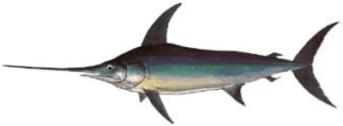
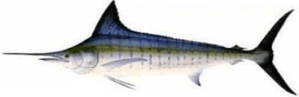

Abstract
The Western and Central Pacific Fisheries Commission (WCPFC) adopted Conservation and Management Measure 2024-06 (CMM 2024-06) to rebuild the Western and Central North Pacific Ocean (WCNPO) striped marlin stock. This measure sets an annual catch limit of 2,400 metric tons (mt) for 2025–2027 with provisions allowing carryover of up to 165 mt per country if catch in a prior year is below the limit. This working paper presents updated rebuilding projections incorporating recent catch data and evaluates three scenarios that include different levels of carryover catches under CMM 2024-06.
Projections were conducted using a stochastic age-structured model (AGEPRO), initialized with 2021–2024 catch data from the WCPFC Yearbook and national submissions, replacing prior assumptions of constant fishing mortality. Recruitment uncertainty was modeled using a three-component mixture distribution. All scenarios shared the same life history, selectivity, and recruitment configurations as the 2024 ISC rebuilding analyses, with differences only in catch levels.
The baseline scenario assumed no carryover, while Scenarios 2 and 3 included catch carryovers in 2025 only, and 2025–2026, respectively. Each scenario adjusted future catches in 2028–2034 to maintain a ≥60% probability of rebuilding the stock to the target spawning biomass (20% of unfished levels) by 2034.
Projections indicate that the striped marlin stock likely exceeded the rebuilding target by 2023 due to low catches and strong 2018–2020 recruitments. However, carryover provisions in 2025–2026 increased short-term fishing mortality, reduced spawning biomass, and elevated the risk of overfishing. Scenario 3 (two years of carryover) required the greatest long-term catch reductions and showed the largest variability in biomass and fishing mortality. Overall, the analyses demonstrate that while carryover provisions provide short-term flexibility, they also increase biological risk and necessitate more conservative future harvests to ensure rebuilding goals are achieved.
Introduction
The Western and Central Pacific Fisheries Commission adopted Conservation and Management Measure (CMM) 2024-06 for Western and Central North Pacific Ocean (WCNPO) striped marlin at the 21st Commission meeting. CMM 2024-06 superseded CMM 2010-01 with a total catch limit of 2400 mt for WCPFC countries during 2025-2027 along with provisions for carryover catches if observed catches were under the catch limit. Under CMM 2024-06 (https://cmm.wcpfc.int/measure/cmm-2024-06), Commission Members, Cooperating Non-Members, and Participating Territories (CCMs) agreed to ensure that the total catch WCNPO striped marlin will not exceed 2400 mt of catch for each year between 2025 – 2027. This catch limit is based on a 60% reduction from the highest catch between 2000 and 2003. If CCMs cumulatively catch in excess of 2400 mt in any given year, the CMM 24-06 will be reviewed the following year. The CMM 24-06 is planned to be reviewed and amended as needed in 2027, pending the completion of a new stock assessment conducted by the ISC.
This working paper analyzes three alternative rebuilding scenarios under CMM 2024-06 which provides for carryover allowances if WCNPO striped marlin catch limits are not exceeded in a year. In particular, if the annual catch limit of 2,400 metric tons of striped marlin is not fully utilized in a given year, then CCMs may carryover up to 165 metric tons of their individual quota to the following year. CMM 24-06 states that “In 2023, there was an 826 mt underage of the TAC of 2400 mt that will be available to CCMs fishing in 2025. Any underage from 2024 will be available to CCMs in 2026, and any underage from 2025 will be available to CCMs in 2027.” Potential catch underages in 2024 and 2025 would lead to carryover catches in 2026 and 2027, respectively. However, no CCM may exceed a 165 metric ton increase in any carryover year, and any overage of an individual limit would be deducted from that country's catch limit in the subsequent year. This working paper describes rebuilding projections to analyze three scenarios for potential catch underages and subsequent carryover of striped marlin catches during 2025-2027. Overall, the goal is to show how projected striped marlin rebuilding outcomes would change under different carryover catch scenarios.
The ISC Billfish Working Group (BILLWG) reviewed CMM 2024-06 at its January 2025 meeting and agreed to analyze three additional projection scenarios to measure the impacts of including carryover catches for 2025-2027 in striped marlin rebuilding analyses. The first scenario represented a constant annual catch of 2400 mt with no carryover during 2025-2027 (Table 1, Figure 1). Scenario 1 catches in 2028-2031 and 2032-2034 were set at 2300 mt and 2200 mt, respectively, to illustrate reaching at least a 60% probability of achieving the striped marlin rebuilding target in 2034. The second scenario set catch at 3225 mt in 2025 and 2400 mt during 2026-2027. Scenario 2 represented a catch measure with carryover in 2025 from 2023 (Table 1, Figure 1). Scenario 2 catches in 2028-2031 and 2032-2034 were set at 2200 mt to illustrate reaching at least a 60% probability of meeting the striped marlin rebuilding target in 2034. The third scenario set catch at 3225 mt in 2025-2026 and 2400 mt during 2027. Scenario 3 represented a catch measure with carryover in 2025-2026 (Table 1, Figure 1). Scenario 3 catches in 2028-2031 and 2032-2034 were set at 2150 mt to illustrate reaching at least a 60% probability of achieving the striped marlin rebuilding target in 2034. Overall, these scenarios showed how potential carryover catches during 2025-2026 would affect stock rebuilding under CMM 2024-06.
Methods
The 2024 rebuilding analyses for WCNPO striped marlin were modified to run the three projections. The CMM 2024-06 projections used the exact same projection model configuration as used in the 2024 striped marlin rebuilding analyses (Brodziak 2024), which in turn were developed from the results of the 2023 benchmark stock assessment (ISC BILLWG 2023).
Projection Model
Rebuilding projections for WCNPO striped marlin were conducted using an age-structured projection model (Brodziak et al. 1998). This stochastic projection model can account for uncertainty in initial population size, future variability in recruitment, and process errors in life history and fishery selectivity parameters (AGEPRO software available at: https://nmfs-fish-tools.github.io/AGEPRO/). Uncertainty in the initial striped marlin population size in 2021 was characterized by calculating 100 bootstrap replicates of population size at age using the bootstrapping option in the assessment model Stock Synthesis ([SS3], Methot and Wetzel 2013, https://nmfs-ost.github.io/ss3-website/). This produced a sampling intensity of about 60 bootstraps per 1,000 mt of spawning biomass and generated a distribution of initial population sizes at age in 2021 for the projections. Future variability in recruitment was modeled as a 3-model finite mixture distribution of short- (12%), medium- (84%), and long-term (4%) recruitment dynamics. In each projection, 1000 simulations were run for each bootstrap replicate to characterize the effects of process errors in future recruitment (Figure A1) as well as life history and fishery parameters (Brodziak 2024). The stochastic projections used the 2023 assessment estimates of the multi-fleet, fishery selectivities at age by fleet group (Tables 2 and 3) to produce consistent results. In each projection, life history parameters at age were randomly sampled using a multiplicative lognormal error with a mean of unity and a CV of 10% to represent future process error, with the exception of maturity at age, which was sampled with a CV of 1%. Similarly, fishery selectivity at age parameters was sampled with a multiplicative lognormal process error with a mean of unity and a CV of 10% to represent process error in future fishery selectivity patterns. Overall, the projections for the CMM 2024-06 scenarios used the same input data and model configurations used by the ISC Billfish Working Group for the 2024 rebuilding analyses, with the exception of the initial harvests during 2021-2024.
Catch Data
We used the most recent catch data to update the initial harvest information from the 2024 rebuilding analyses. In particular, the input catch data used for the three scenarios differed from those used in the 2024 rebuilding analyses in two ways. First, we collected new catch data during 2021-2024 to calculate spawning biomasses and fishing mortalities (F) during 2021-2024 from the last year of the stock assessment in 2020. In this case, the reported catch data during 2021-2024 replaced the status quo fishing mortality that was used to project harvests of WCNPO striped marlin in 2021-2024 in the 2024 rebuilding analyses (Brodziak 2024). Second, the average proportion of catch by country and assessment fleet group in 2020 was used to apportion catch by country to fleet groups during 2025-2027 (Tables 2 and 3, Figures 2.1-2.9). This apportionment was needed because two countries, Japan and Taiwan, both had fishing fleets in more than one assessment fleet group. As a result, the three scenarios used 2021-2024 catch data to initialize the projection runs, applied the scenario-specific catch allocations in 2025-2027, and then set catches during 2028-2034 to rebuild striped marlin with at least a 60% probability in 2034.
We set the input WCNPO striped marlin catch data in 2021-2023 based on the 2024 WCPFC Tuna Fishery Yearbook (WCPFC 2024, https://www.wcpfc.int/doc/wcpfc-tuna-fishery-yearbook-2024) for all CCMs reporting striped marlin catches, except Japan and the U.S which provided catch data from 2021 through 2024. The WCPFC Yearbook data was considered to provide the best information on recent catches of WCNPO striped marlin in the WCPFC Area north of the equator by China, Kiribati, Korea, Marshall Islands, Nauru, Vanuatu, and Taiwan during 2021-2023 (Figures 3.1 and 3.2). We note that the 2024 striped marlin catches are not reported in the 2024 Tuna Fishery Yearbook. As a result, the WG agreed to impute the striped marlin catches in 2024 which were set equal the reported 2023 catch values for each country.
Japanese catch data during 2021-2024 were based on reported catches gathered from each of the 15 Japanese fleets (Table 2) and 7 fleet groups (Table 3, Figures 2.1 to 2.7 and 4.1) defined in the most recent striped marlin stock assessment (ISC BILLWG 2023). Reported catches by fleet were based on catch data collected from the most recent 2025 database sources (Table 4, M. Jusup, personal communication, February 26, 2025).
The U.S. catch data for 2021-2024 were based on reported catches for the Hawaii commercial longline fleet and for the Hawaii recreational fleet (Table 2, Figure 2.8). Reported catches by fleet were based on catch data collected from the most recent 2025 database sources (Table 5 and Figure 4.2).
Annual striped marlin catch data by fishing fleet for 2021-2024 were allocated to the 9 fleet groups used in the 2023 WCNPO striped marlin stock assessment (Table 2, Figures 2.1-2.9). Catches by fleet for each country were uniquely assigned to a single fleet group for all countries, except Japan and Taiwan. Japanese catches by fleet in 2021-2024 were assigned to fleet group based on the observed proportion of Japanese catch by fleet group in 2020 (Table 6 and Figure 5.1). Taiwanese catches by fleet in 2021-2024 were assigned to fleet groups G7 and G9 (Figures 2.7 and 2.9) based on the observed proportions of Taiwanese catch biomass by fleet group in 2020 (Figure 5.2), which were 9% and 91%, respectively. This led to the best available information on observed striped marlin catch biomasses in 2021-2024 (Table 7). For comparison, these observed catches were contrasted with the predicted catches from the 2024 rebuilding analyses which were based on an assumed constant fishing mortality during 2021-2024. Overall, each CMM 2024-06 catch scenario used the same observed catches and fleet group allocations to initialize the projections in 2021-2024.
Projected striped marlin catches by country during the 2025-2027 CMM 2024-06 phase were allocated to the 9 fleet groups based on the maximum CMM 2024-06 carryover catch values under each scenario. For the first scenario with no carryover catch, annual striped marlin catches were set at 2400 mt during 2025-2027 (Table 1). Under the second scenario with carryover catch in 2025, annual catches were set at 3225 mt in 2025 and at 2400 mt in 2026-2027. For the third scenario with carryover catches in 2025-2026, annual catches were set at 3225 mt in 2025-2026 and at 2400 mt in 2027.
Catches during the second (2028-2031) and third (2032-2034) phases of the projection time horizon were set to ensure that a rebuilding probability of at least 60% was achieved in 2034. Noting that the CMM 2024-06 is planned to be amended if needed in 2027, annual catches in rebuilding phases 2 and 3 under Scenarios 2 and 3 were reduced from the status quo catch of 2400 mt by an amount sufficient to achieve the rebuilding target.
Results
We compared the initial reported catches used in the CMM 2024-06 projections to the initial projected catches used for the 2024 rebuilding projections. For the CMM 2024-06 projections, observed annual catches during 2021-2023 and imputed catches for 2024 were based on the 2024 WCPFC Yearbook data, except for Japan and the U.S., which updated catches in 2025. The annual catches used for the CMM 2024-06 projections were 1540 (2021), 1470 (2022), 1685 (2023), and 2157 mt (2024). For the 2024 rebuilding projections, the recent average fishing mortality during 2018-2020 was used to set the initial catches during 2021-2024. Under this assumption of status quo fishing mortality, the projected median catches during 2021-2024 were 2910, 3380, 3320, and 3030 mt, respectively (Brodziak 2024, Table 10.9, Scenarios 1-6). In comparison, the observed catches in 2021-2024 for the CMM 2024-06 projections were 48%, 57%, 50%, and 30% below the predicted catches in 2021-2024 from the 2024 rebuilding projections (Table 8, Figure 6.1). Similarly , the fishing mortalities in 2021-2024 under the CMM 2024-06 projections were 23%, 45%, 44%, and 38% below the recent average fishing mortality used in the 2024 rebuilding projections (Figure 6.2). As a result, the CMM 2024-06 projections were initialized in 2021-2024 (Figure 6.2) with substantially lower catches and fishing mortalities than the 2024 rebuilding projections.
Projected spawning biomass
The WCNPO striped marlin stock was projected to have achieved the target spawning biomass of 20%SSBF=0 =3660 mt with probability greater than 60% before the onset of CMM 2024-06 in 2025. Projected spawning biomass increased rapidly from a median of about 2640 mt in 2021 to a median of about 5720 mt in 2024 under each catch carryover scenario (Tables 9.1-9.3, Figures 7.1-7.4). Stock rebuilding probabilities during 2021-2024 were roughly 6%, 67%, 94%, and 91%, respectively (Table 10, Figures 7.1-7.4). Overall, the CMM 2024-06 projections indicated that it was very likely that the stock exceeded the rebuilding target in 2023-2024.
Projected spawning biomass decreased in 2025-2027 under each CMM 2024-06 scenario. Median spawning biomasses in 2027 under Scenarios 1, 2, and 3 declined to about 4700, 4200, and 3700 mt from a projected high of about 5700 mt in 2024 (Tables 9.1-9.3, Figures 7.4-7.7 and 10.1-10.3) . Median spawning biomass declined by 18% from 2024 to 2027 with no carryover catch in Scenario 1. Declines in median spawning biomass were 26% and 36% under the carryover catch Scenarios 2 and 3. In comparison, there was a 2-fold difference in the percent reduction in spawning biomass for Scenario 3 versus Scenario 1. The magnitude of variability of spawning biomasses appeared relatively similar across scenarios during 2025-2027 (Figures 8.1-8.3). Probabilities of spawning biomass being above the rebuilding target in 2025-2027 remained above the 60% target probability under Scenarios 1 and 2 (Table 10, Figures 9.1-9.2) but fell to 50% in 2027 under Scenario 3 (Table 10, Figure 9.3), or about 10% below the 60% target probability.
While the rebuilding target in 2034 was likely to be achieved in 2023-2024, the projected spawning biomass trajectories during 2028-2034 depended on the carryover catch scenario. Under Scenario 1, the WCNPO striped marlin catch was 2300 mt of annual catch during 2028-2031 and 2200 mt during 2031-2034 for a total of 15800 mt. This catch series led to a gradual decline in median spawning biomass from 4515 mt in 2028 to 4191 mt (Table 9.1, Figure 10.1) in 2034 with a rebuilding probability of 60% (Table 10, Figure 10.1). For Scenario 2, the WCNPO striped marlin catch was constant at 2200 mt during 2028-2034 for a total of 15400 mt. This catch level led to a slight increase in median spawning biomass from 4184 mt in 2028 to 4249 mt (Table 9.2, Figure 10.2) in 2034 with a rebuilding probability of 61% (Table 10, Figure 10.2). The WCNPO striped marlin catch under Scenario 3 was constant at 2150 mt during 2028-2034 for a total of 15050 mt. This catch level led to an increase in median spawning biomass from 3743 mt in 2028 to 4306 mt (Table 9.3, Figure 10.3) in 2034 with a rebuilding probability of 63% (Table 10, Figure 10.2).
Projected fishing mortality
Fishing mortality on the WCNPO striped marlin stock was projected to be below a limit reference level of F_{20%SSB(F=0)} = 0.53 during 2021-2024. Median fishing mortalities were 0.33, 0.23, 0.23, and 0.25 in 2021-2024, respectively (Tables 10.1-10.3). Fishing mortality was very likely below F_{20%SSB(F=0)} under each catch carryover scenario (Tables 10.1-10.3, Figures 7.1-7.4). Probabilities of exceeding the limit reference level during 2021-2024 were roughly 1%, 0%, 0%, and 1%, respectively (Table 11.2, Figures 7.1-7.4). Overall, the CMM 2024-06 projections indicated that it was very likely that the stock was not experiencing excess fishing mortality in 2021-2024.
Projected fishing mortality increased in 2025-2027 under each CMM 2024-06 scenario. Median fishing mortality in 2027 under Scenarios 1, 2, and 3 increased to about 0.32, 0.35, and 0.39 from F=0.25 in 2024 (Tables 10.1-10.3, Figures 7.4-7.7 and 10.1-10.3) . Median F increased by 28% from 2024 to 2027 with no carryover catch under Scenario 1. Median Fs increased by 40% and 56% under the carryover catch Scenarios 2 and 3. In comparison, there was a 2-fold difference in the percent increase in median F for Scenario 3 versus Scenario 1. The variability of fishing mortality increased with the amount of carryover catch across scenarios during 2025-2027 with Scenario 1 being the least variable and Scenario 3 being the most variable (Figures 8.1-8.3). Probabilities of fishing mortality exceeding the limit reference level in 2025-2027 (Tables 10.1-10.3, Figure 11.2) were highest under Scenario 3 (40% in 2026) and lowest under Scenario 1 (4% in 2025).
The projected fishing mortality distributions stabilized under each scenario during 2028-2034. Under Scenario 1, median F varied about F=0.32 from 2028-2034 (Table 10.1, Figure 10.1). The median F under Scenario 2 was similar and equaled F=0.32 during 2028-2034 (Table 10.2, Figure 10.2). Under Scenario 3, the median F decreased 11% from F=0.35 in 2028 to F=0.31 in 2034. Overall, projected fishing mortalities at the end of the period were similar and likely below the limit reference level under each scenario.
Discussion
The WCNPO striped marlin stock was projected to have very likely achieved the rebuilding target in 2023, prior to the adoption of CMM 2024-06. This result of rapid rebuilding differs from the results of the 2024 rebuilding projections which indicated that the stock would require a longer period to achieve the target with 60% probability. For example, under Scenario 6 from Brodziak (2024, Figure 37.6) which applies a phased harvest control of 2400 mt of catch during 2025-2027, 2200 mt during 2028-2031, and 2150 mt in 2031-2034 (Figure 12). The primary reason for the difference in rebuilding periods was the 47% reduction in total catch biomass in 2021-2024 used to initialize the CMM 2024-06 projections. The reduction in catches coincided with the maturation of the above-average recruitment strengths of the 2018-2020 year classes of WCNPO striped marlin. In particular, the 2018-2020 year classes were a marked change from the pattern of long-term decline in recruitment (Figure 13.1). The recent increase in recruitment combined with the decrease in catch biomass to the lowest observed levels in 2021-2023 substantially increased the probability that spawning biomass would increase during 2021-2024. In particular, the above-average year classes from 2018-2020 were expected to be very likely fully mature in 2021-2023, respectively, based on an age of 95% maturity of about 3 years (ISC BILLWG 2023, Humphreys and Brodziak 2024). For example, the 2020 year class was about 54% larger than the short-term average, even though it was well below the long-term average of about 300 thousand fish (Figure 14). Overall, the CMM 2024-06 projections indicated that reduced catches and fishing mortality on the 2018-2020 year classes of WCNPO striped marlin were very likely to have rebuilt the stock in 2023.
Increasing carryover catch allowances in 2025–2026 led to substantial changes in stock rebuilding dynamics, overfishing risks, and the variability of key population indicators. Under Scenario 1 (no carryover), the probability of rebuilding WCNPO striped marlin to the target biomass by 2034 was 60%, with a relatively low overfishing probability of about 8% in 2026. Scenario 2, which allowed a one-time carryover of 825 mt in 2025, almost doubled the 2026 overfishing probability to around 14%. Scenario 3, which includes carryover in both 2025 and 2026, resulted in the highest overfishing probability, 40% in 2026, a fivefold increase over Scenario 1.. This pattern highlights a trade-off between short-term catch gains and conservation risks. Overall, the scenarios illustrate that short-term catch increases from carryover provisions would temporarily boost yield but would also require stricter long-term harvest reductions and incur higher risks of exceeding biological limits in the interim.
Carryover catch also increased the variability of both spawning biomass and fishing mortality during 2025–2027. In Scenario 1, the projected spawning biomass declined by 18% from 2024 to 2027, with the narrowest spread in projected outcomes. Scenario 2 saw a 26% decline in median biomass and wider interquartile ranges. Scenario 3 exhibited the sharpest median biomass decline (36%) and the broadest distribution of outcomes, reflecting greater uncertainty due to elevated harvests. Similarly, fishing mortality variability increased with carryover intensity. The range and interquartile spread of fishing mortality widened substantially from Scenario 1 to 3, with Scenario 3 showing the greatest dispersion and highest median F values in 2025–2027. Despite these short-term impacts, all three scenarios required catch reductions in 2028–2034 to maintain at least a 60% rebuilding probability by 2034. Total projected catch in that period had to be reduced by 2.5% under Scenario 2 and 4.7% under Scenario 3 relative to Scenario 1. Overall, the results illustrate that while carryover provisions allow short-term catch increases, they amplify variability in key biological indicators, raise the probability of overfishing, and would require more conservative long-term harvests to ensure rebuilding success.
References
Brodziak J, Rago P, Conser R. 1998. A general approach for making short-term stochastic projections from an age-structured fisheries assessment model. In F. Funk, T. Quinn II, J. Heifetz, J. Ianelli, J. Powers, J. Schweigert, P. Sullivan, and C.-I. Zhang (Eds), Proceedings of the International Symposium on Fishery Stock Assessment Models for the 21st Century. Alaska Sea Grant College Program, Univ. of Alaska, Fairbanks. Available at: https://www.researchgate.net/publication/267682539_A_General_Approach_for_Making_Short-Term_Stochastic_Projections_from_an_Age-Structured_Fisheries_Assessment_Model
Brodziak J. 2024. Rebuilding Scenarios for striped marlin in the Western and Central North Pacific Ocean. International Scientific Committee for Tuna and Tuna-Like Species in the North Pacific/Billfish WG, ISC/24/BILLWG-01/03, 151 p. Available at: https://isc.fra.go.jp/pdf/BILL/ISC24_BILL_1/ISC_24_BILLWG-01_03.pdf
Humphreys RL Jr and Brodziak JKT. 2024. Reproductive dynamics of striped marlin (Kajikia audax) in the central North Pacific. Marine and Freshwater Research 75, MF23192. https://doi:10.1071/MF23192
ISC Billfish Working Group [ISC BILLWG]. 2023. Annex 14: Stock Assessment Report for striped marlin (Kajikia audax) in the Western and Central North Pacific Ocean through 2020, 12-17 July 2023. Kanazawa, Japan. ISC/23/Annex14, 113 p. Available at: https://isc.fra.go.jp/pdf/ISC23/ISC23_ANNEX14-Stock_Assessment_Report_for_WCNPO_Striped_Marlin-FINAL.pdf
Methot RD, Wetzel CR. 2013. Stock Synthesis: a biological and statistical framework for fish stock assessment and fishery management. Fish. Res., 142, 86–99. https://doi.org/10.1016/j.fishres.2012.10.012.
Table 1. Three carryover catch scenarios for rebuilding WCNPO striped marlin in 2034 with alternative carryover catches (mt) during 2025-2027 under CMM 24-06.

Table 2. Fishing fleets and fleet groups with equal fishery selectivity used in the base case model of the 2023 stock assessment and in the 2025 rebuilding scenarios under CMM 24-06, where the representative fishery selectivity fleet for each fleet group is shown in bold.

Table 3. WCNPO striped marlin catch biomass (mt) by assessment fleet group and fleet in 2020.

Table 4. Japanese catch biomass (mt) of WCNPO striped marlin by fleet group, 2021-2024.

Table 5. U.S. catch biomass (mt) of WCNPO striped marlin, 2021-2024.

Table 6. Total and proportion of WCNPO striped marlin catch biomass in 2020 by assessment fleet group along with Japanese total and proportion of WCNPO striped marlin catch biomass by fleet group.

Table 7. WCNPO striped marlin catch biomasses (mt) used for 2025 CMM 24-06 projections.

Table 8. Comparison of observed catch biomasses (mt) from WCPFC Tuna Fishery Yearbook 2024, Japan, and the U.S. and projected catches from assuming recent average fishing mortality in the 2024 rebuilding projections.

Table 9.1. Projections of annual spawning biomass distributions (thousand mt) during 2021-2034 under Scenario 1 with no carryover catch where the column heading “Pz” denotes the z^{th} percentile of the annual distributions.

Table 9.2. Projections of annual spawning biomass distributions (thousand mt) during 2021-2034 under Scenario 2 with carryover catch in 2025 where the column heading “Pz” denotes the z^{th} percentile of the annual distributions.

Table 9.3. Projections of annual spawning biomass distributions (thousand mt) during 2021-2034 under Scenario 3 with carryover catch in 2025-2026 where the column heading “Pz” denotes the z^{th} percentile of the annual distributions.

Table 10.1. Projections of annual fishing mortality distributions during 2021-2034 under Scenario 1 with no carryover catch where the column heading “Pz” denotes the z^{th} percentile of the annual distributions.

Table 10.2. Projections of annual fishing mortality distributions during 2021-2034 under Scenario 2 with carryover catch in 2025 where the column heading “Pz” denotes the z^{th} percentile of the annual distributions.

Table 10.3. Projections of annual fishing mortality distributions during 2021-2034 under Scenario 3 with carryover catch in 2025-2026 where the column heading “Pz” denotes the z^{th} percentile of the annual distributions.

Table 11.1. Projections of probabilities of achieving the rebuilding target during 2021-2034 under three scenarios for carryover catch.

Table 11.2. Projections of probabilities of overfishing during 2021-2034 under three scenarios for carryover catch.

Figure 1. Projected distributions of WCNPO striped marlin catch biomass by scenario with median (solid blue lines), interquartile range (dot-dashed lines), 10th and 90th percentiles (dotted blue lines), average catch biomass during 2001-2020 (green dashed line), and approximate 80% confidence intervals (gray shaded region).
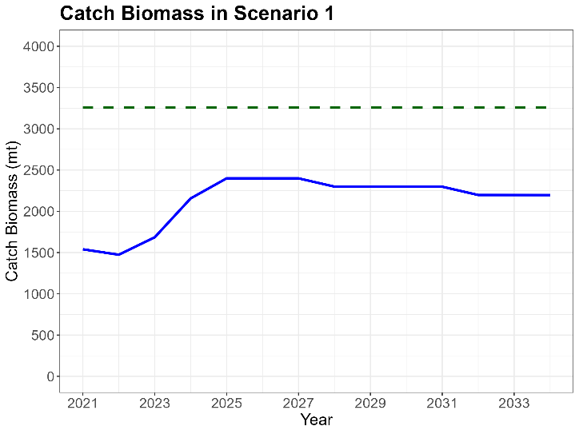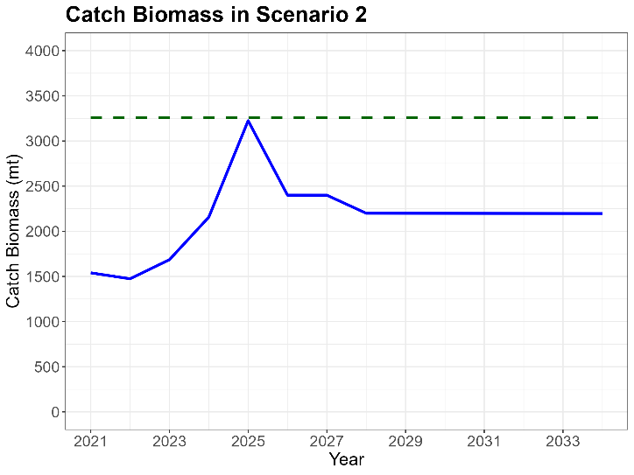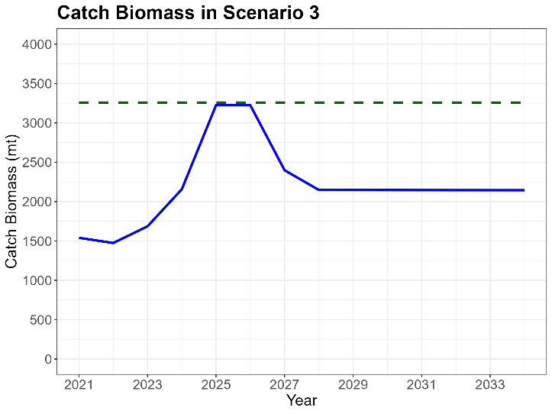
Figure 2.1. Fishing fleets in fleet group 1 (Tables 2 and 3) from the base case model of the 2023 stock assessment and the 3 carryover catch scenarios under CMM 24-06.

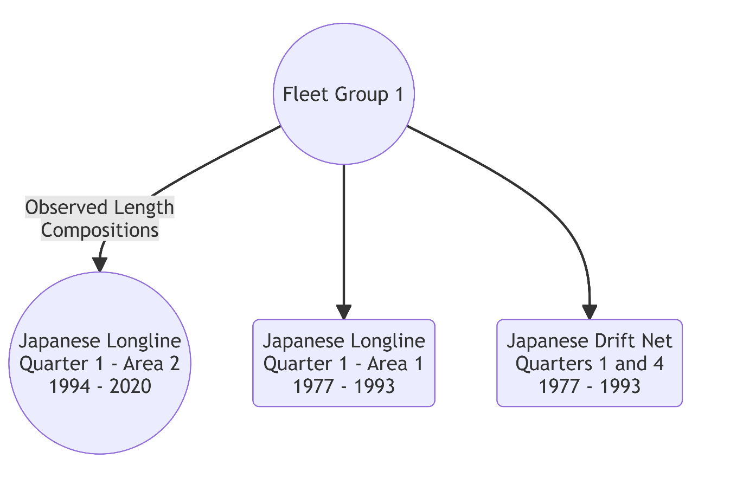

Figure 2.2. Fishing fleets in fleet group 2 (Tables 2 and 3) from the base case model of the 2023 stock assessment and the 3 carryover catch scenarios under CMM 24-06.

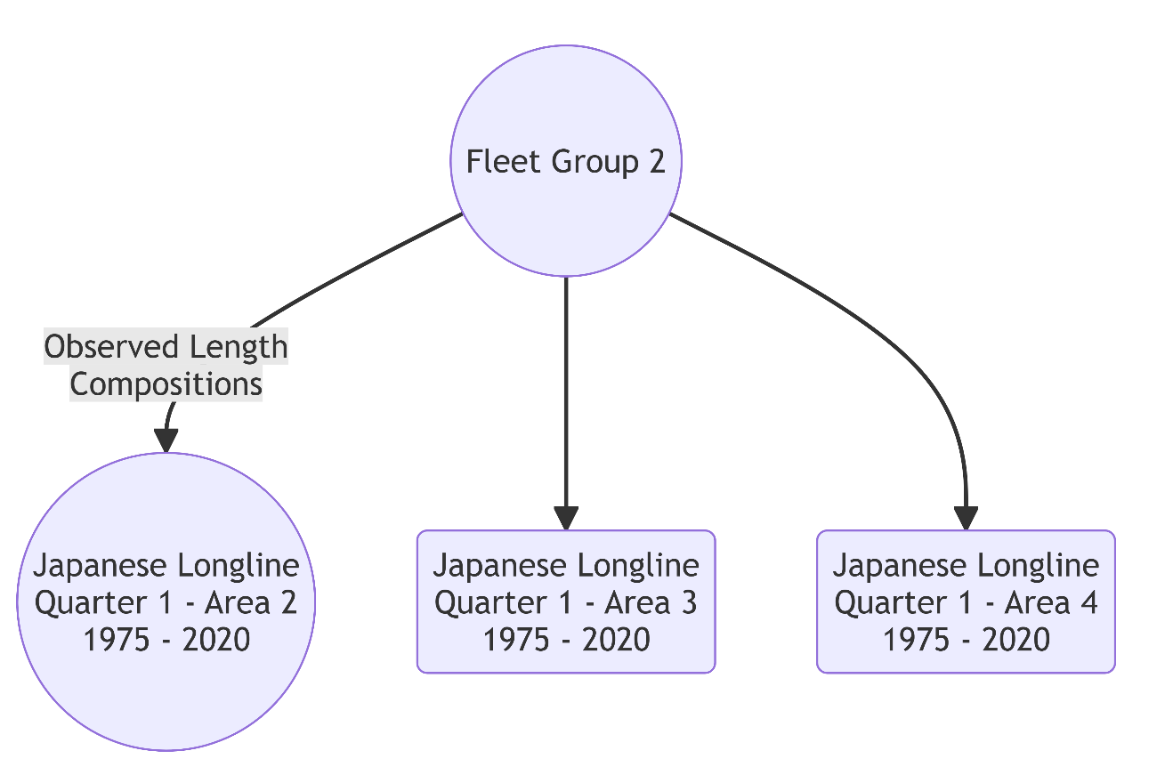

Figure 2.3. Fishing fleets in fleet group 3 (Tables 2 and 3) from the base case model of the 2023 stock assessment and the 3 carryover catch scenarios under CMM 24-06.

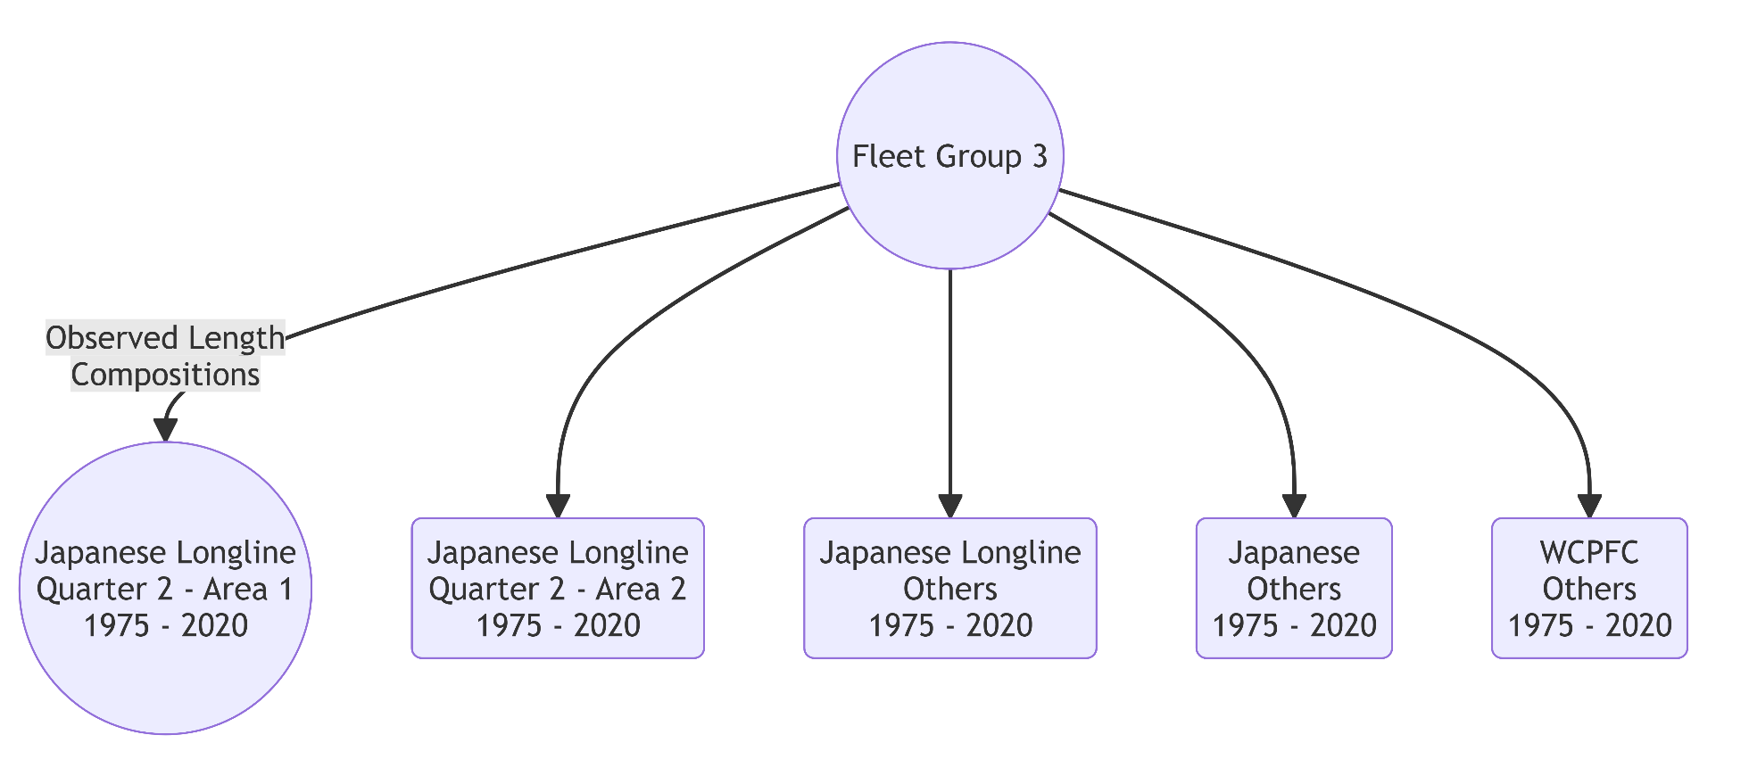

Figure 2.4. Fishing fleets in fleet group 4 (Tables 2 and 3) from the base case model of the 2023 stock assessment and the 3 carryover catch scenarios under CMM 24-06.

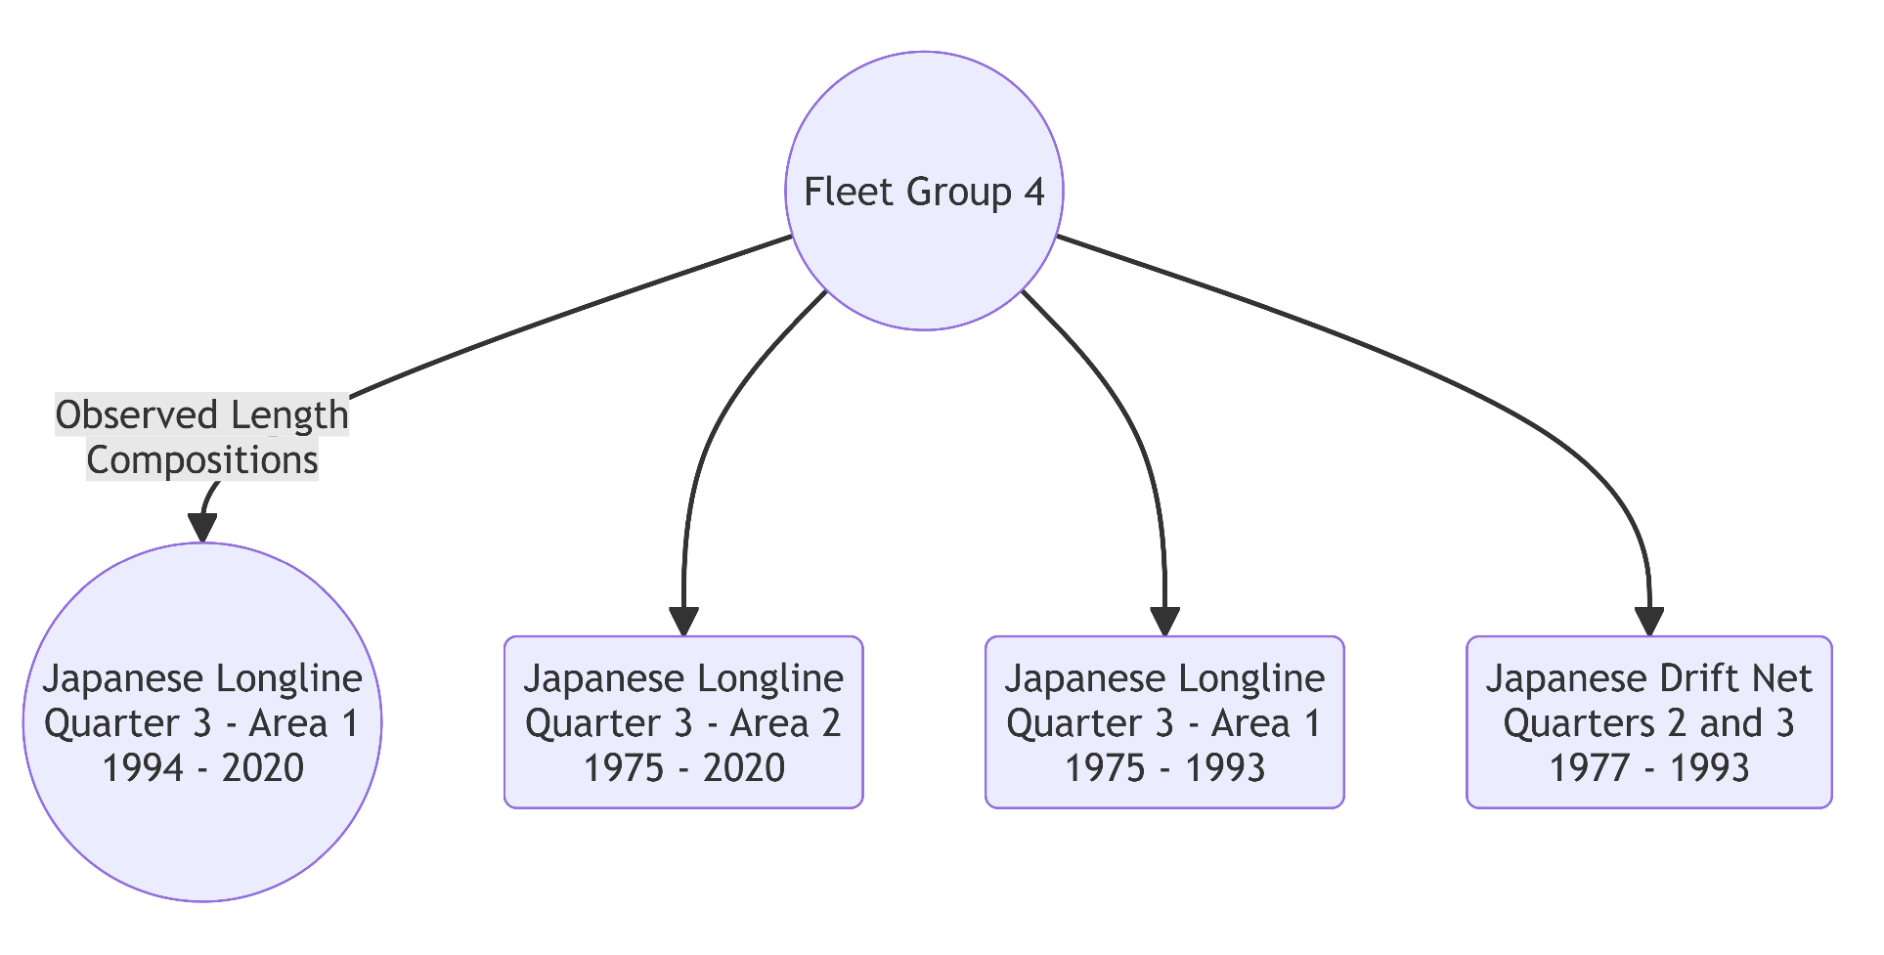

Figure 2.5. Fishing fleets in fleet group 5 (Tables 2 and 3) from the base case model of the 2023 stock assessment and the 3 carryover catch scenarios under CMM 24-06.

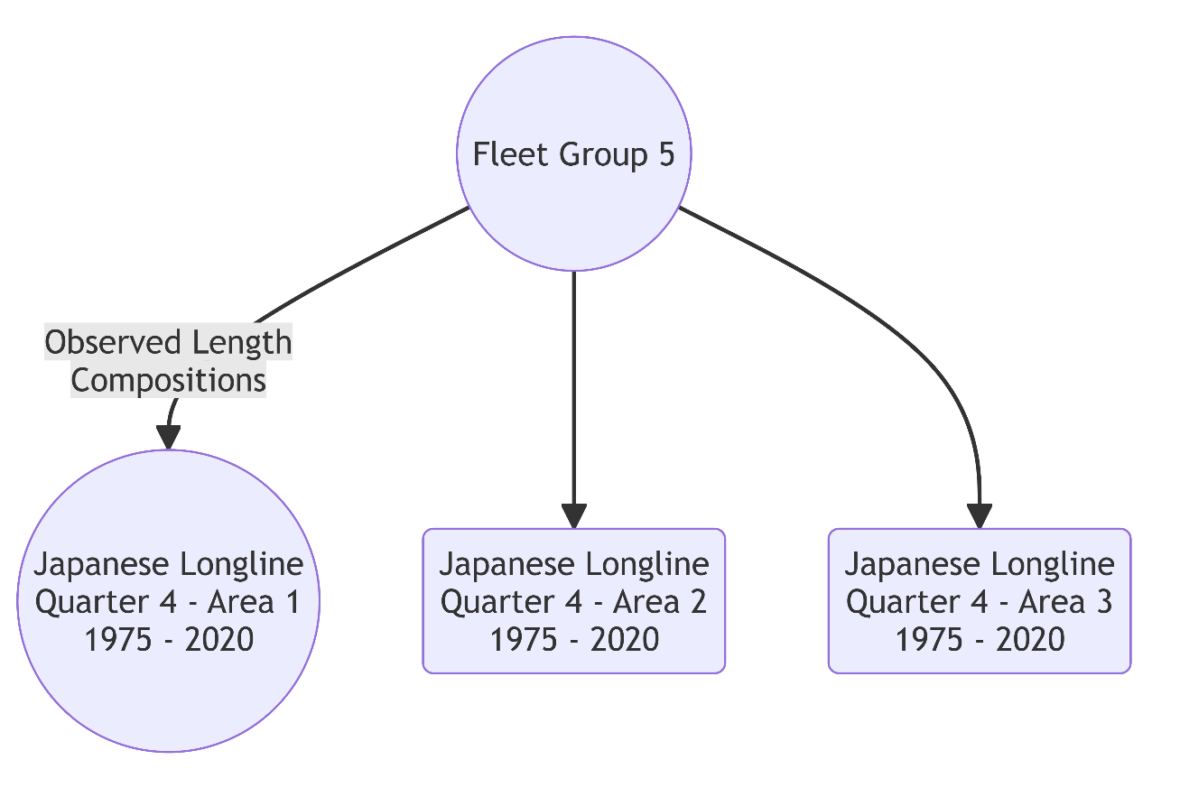

Figure 2.6. Fishing fleets in fleet group 6 (Tables 2 and 3) from the base case model of the 2023 stock assessment and the 3 carryover catch scenarios under CMM 24-06.

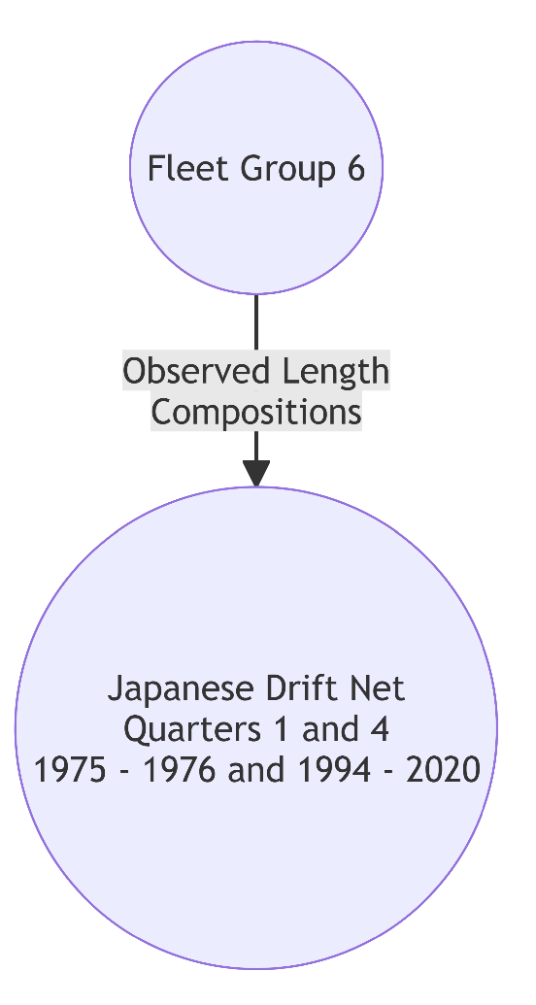

Figure 2.7. Fishing fleets in fleet group 7 (Tables 2 and 3) from the base case model of the 2023 stock assessment and the 3 carryover catch scenarios under CMM 24-06.

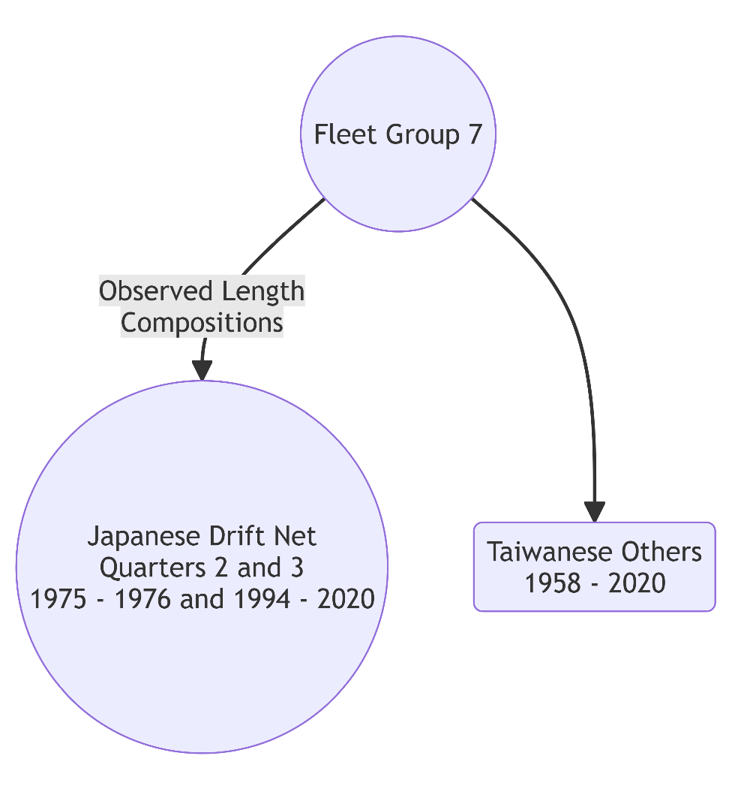

Figure 2.8. Fishing fleets in fleet group 8 (Tables 2 and 3) from the base case model of the 2023 stock assessment and the 3 carryover catch scenarios under CMM 24-06.

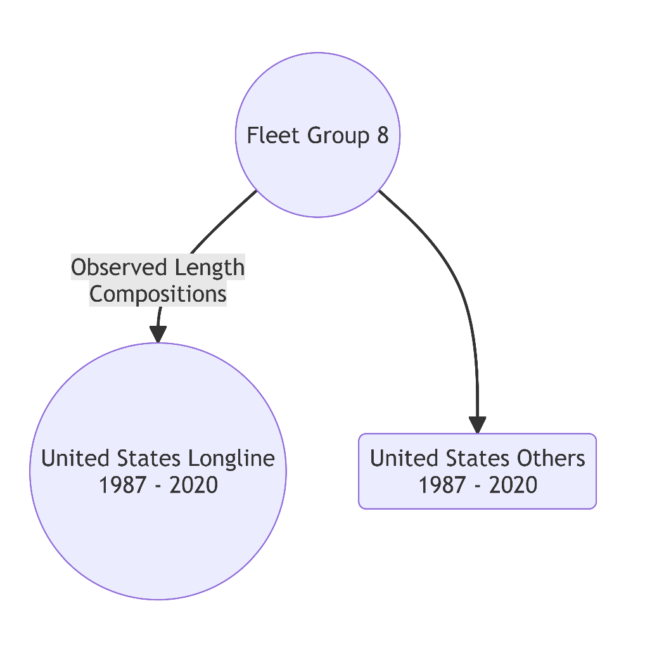

Figure 2.9. Fishing fleets in fleet group 9 (Tables 2 and 3) from the base case model of the 2023 stock assessment and the 3 carryover catch scenarios under CMM 24-06.

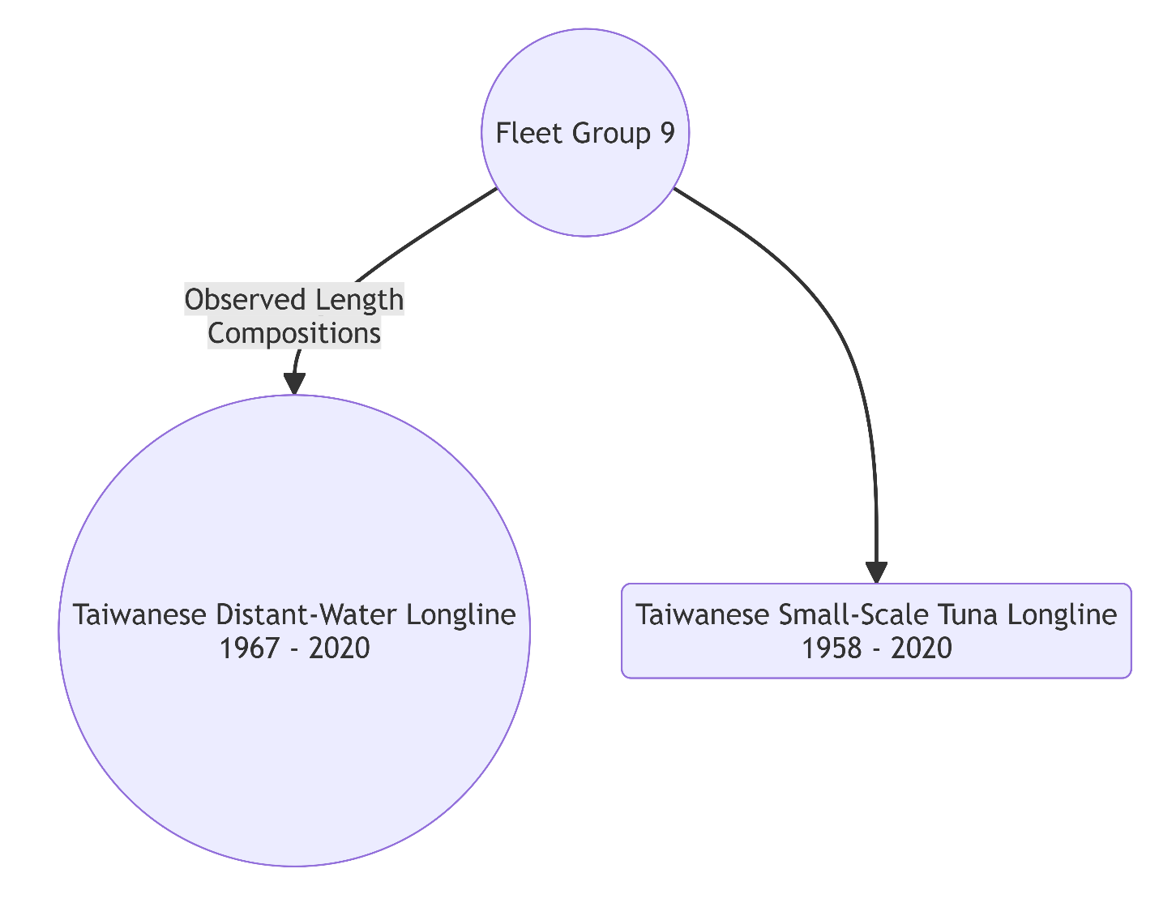

Figure 3.1. Reported WCNPO striped marlin catch biomasses (mt) by WCPFC longline fleets in fleet group 3 (Tables 2 and 3) used in the base case model of the 2023 stock assessment and the 3 carryover catch scenarios under CMM 24-06.

Figure 3.2. Reported WCNPO striped marlin catch biomasses (mt) by Japan, Taiwan, and the U.S. (Tables 2 and 3) from the WCPFC Tuna Fishery Yearbook 2024.

Figure 4.1. Japanese WCNPO striped marlin catch biomass (mt) by fleet group reported to the ISC Billfish Working Group in 2025.

Figure 4.2. U.S. WCNPO striped marlin catch biomass (mt) by fleet group reported to the ISC Billfish Working Group in 2025.

Figure 5.1. Japanese proportion of WCNPO striped marlin catch (mt) by fleet group in 2020.

Figure 5.2. proportion of WCNPO striped marlin catch (mt) by fleet group in 2020.

Figure 6.1. Comparison of observed WCNPO striped marlin catch biomasses in 2021-2024 used in the CMM 2024-06 projections and predicted catch biomasses used in the 2024 rebuilding projections with 80% confidence whiskers.

Figure 6.2. Comparison of predicted WCNPO striped marlin fishing mortalities in 2021-2024 used in the CMM 2024-06 projections with 80% confidence whiskers and status quo fishing mortalities used in the 2024 rebuilding projections.

Figure 7.1. Projected distributions of WCNPO striped marlin female spawning biomass (top) and fishing mortality (bottom) in 2021 with rebuilding target (green solid line), median spawning biomass and fishing mortality (dashed black line), fishing mortality limit (dark blue solid line) and fitted densities (red curve).
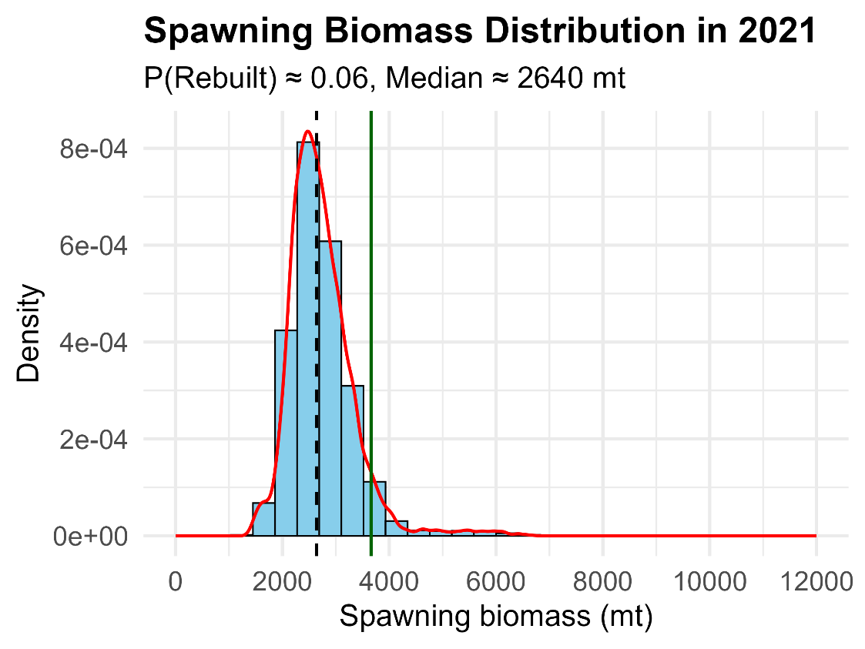
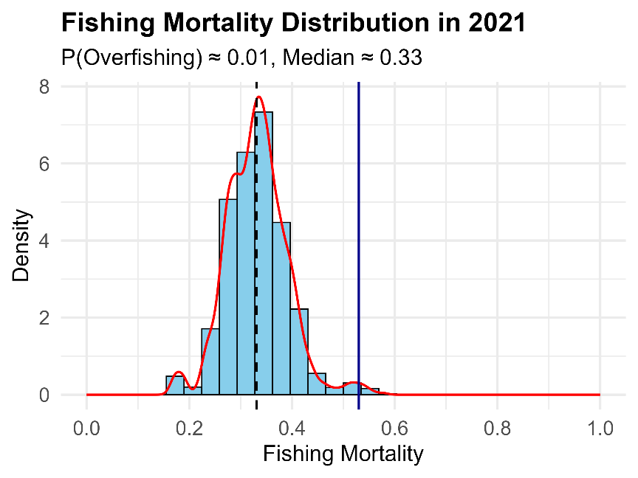

Figure 7.2. Projected distributions of WCNPO striped marlin female spawning biomass (top) and fishing mortality (bottom) in 2022 with rebuilding target (green solid line), median spawning biomass and fishing mortality (dashed black line), fishing mortality limit (dark blue solid line) and fitted densities (red curve).
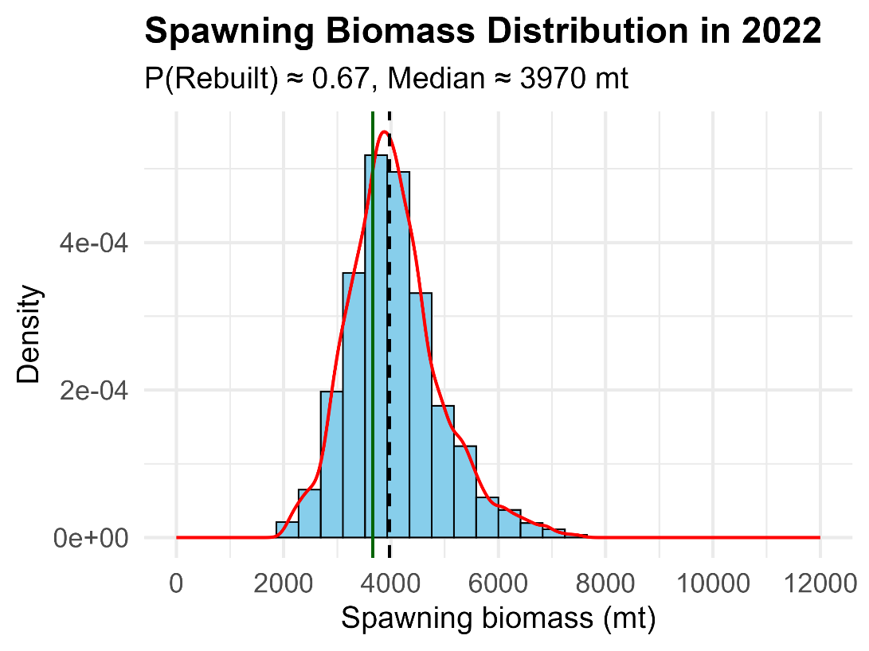
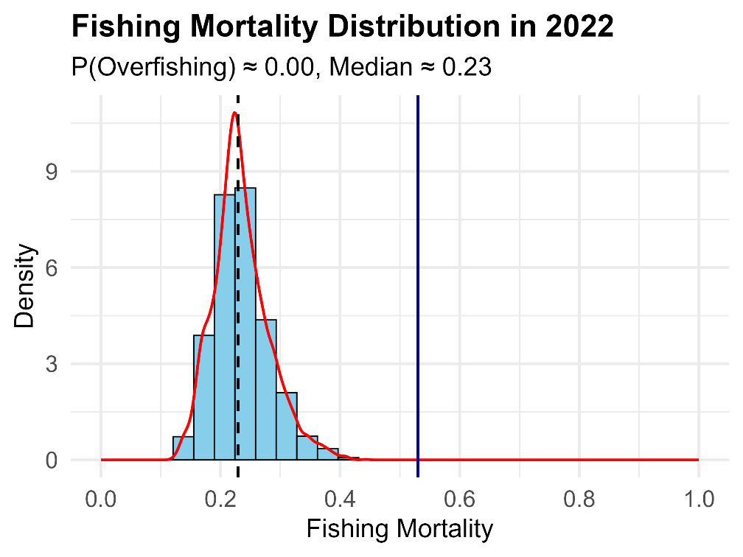

Figure 7.3. Projected distributions of WCNPO striped marlin female spawning biomass (top) and fishing mortality (bottom) in 2023 with rebuilding target (green solid line), median spawning biomass and fishing mortality (dashed black line), fishing mortality limit (dark blue solid line) and fitted densities (red curve).
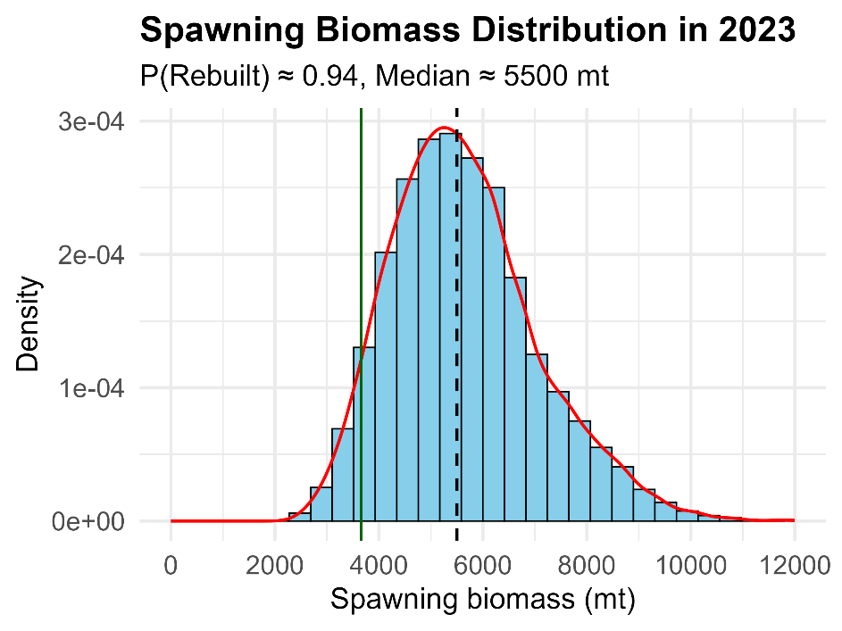
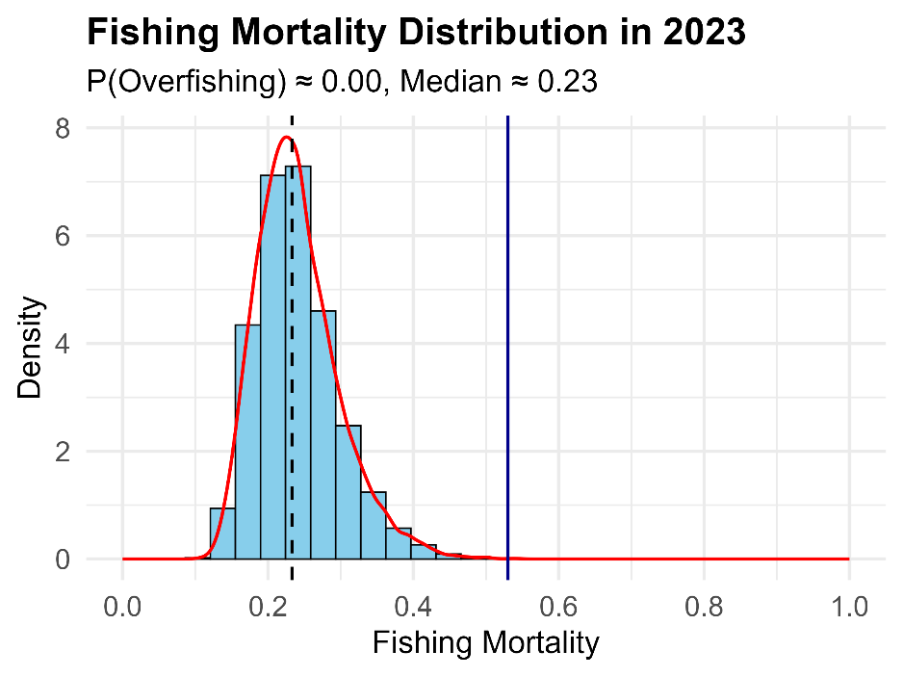
Figure 7.4. Projected distributions of WCNPO striped marlin female spawning biomass (top) and fishing mortality (bottom) in 2024 with rebuilding target (green solid line), median spawning biomass and fishing mortality (dashed black line), fishing mortality limit (dark blue solid line) and fitted densities (red curve).
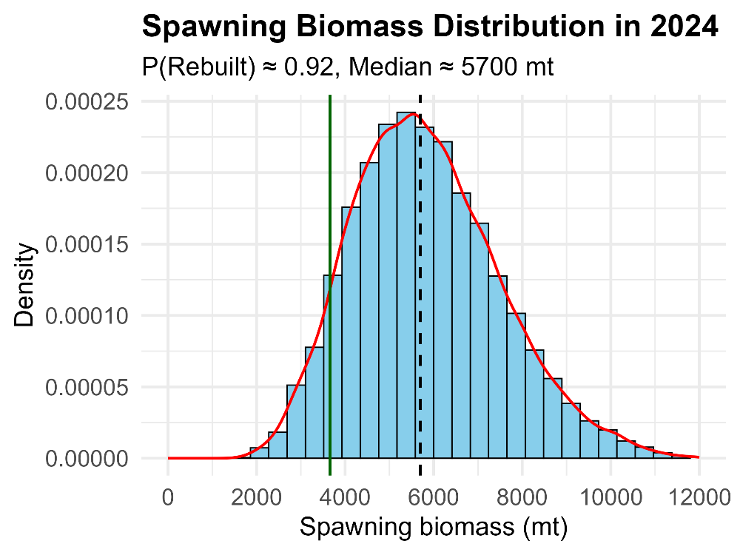
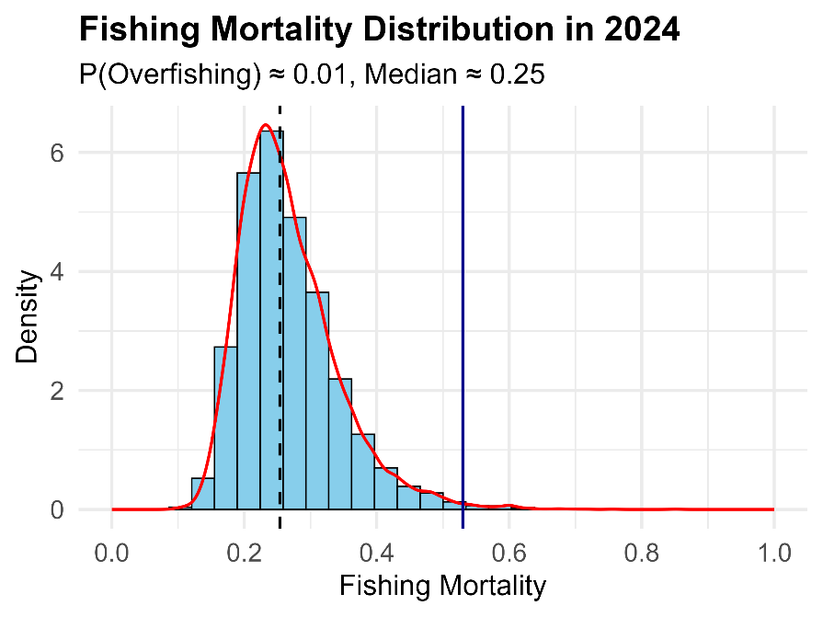
Figure 8.1. Projected distributions of WCNPO striped marlin female spawning biomass in 2025-27 (panels a-c) and 2034 (panel d) under Scenario 1 with no carryover catch and with rebuilding target (green solid line), median spawning biomass and fitted densities (red curve).
(a) (b)
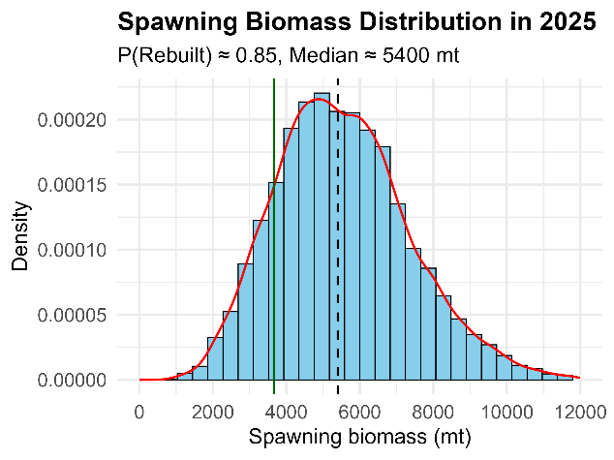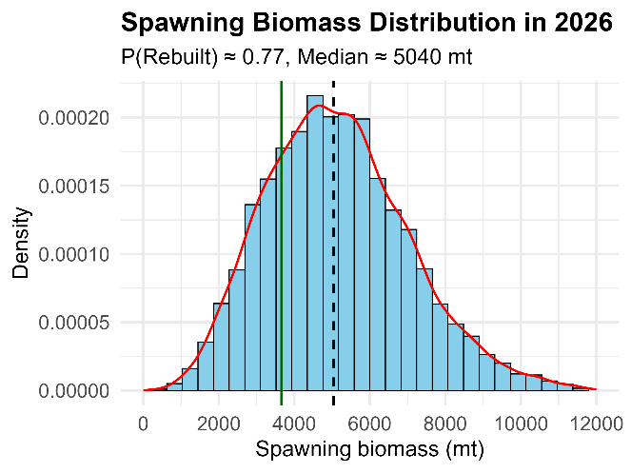
(c) (d)
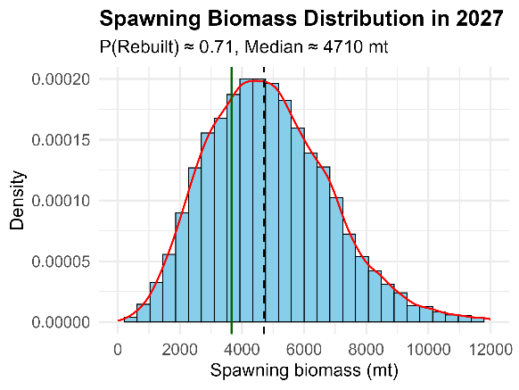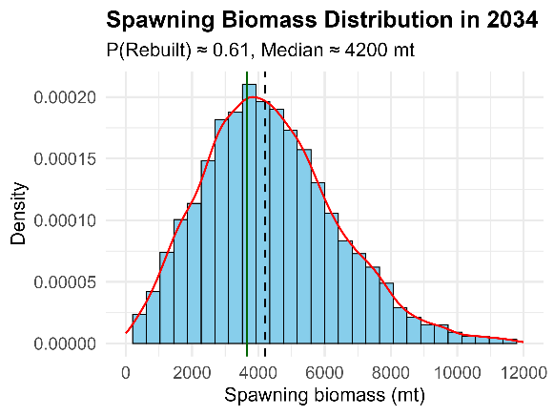

Figure 8.2. Projected distributions of WCNPO striped marlin female spawning biomass in 2025-27 (panels a-c) and 2034 (panel d) under Scenario 2 with 825 mt of carryover catch in 2025 and with rebuilding target (green solid line), median spawning biomass and fitted densities (red curve).
(a) (b)
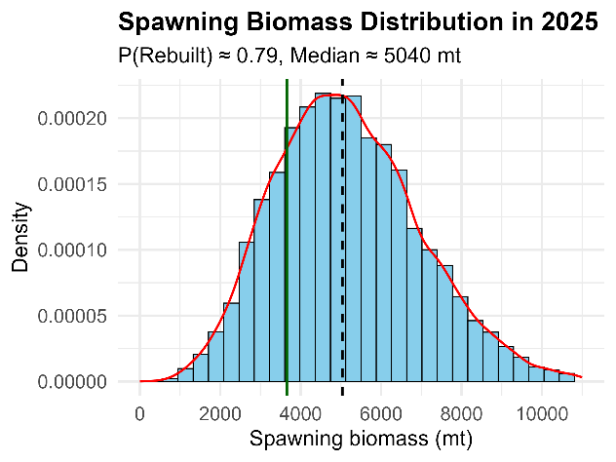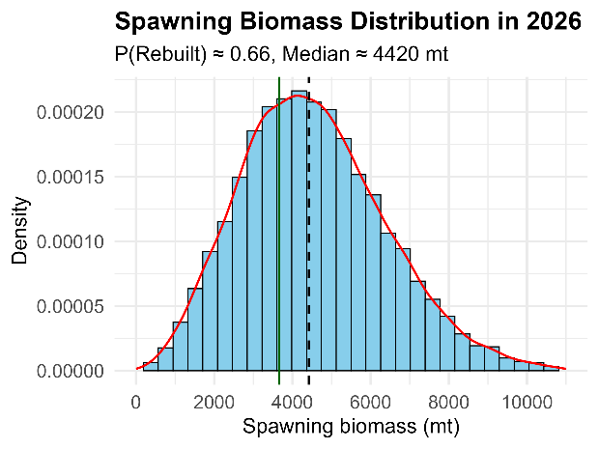
(c) (d)
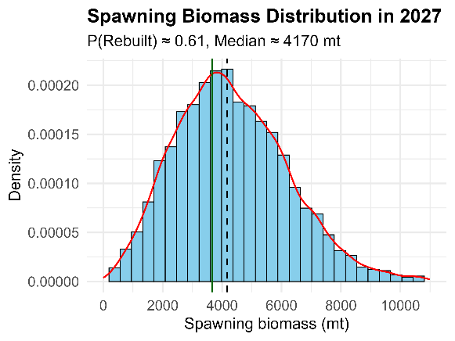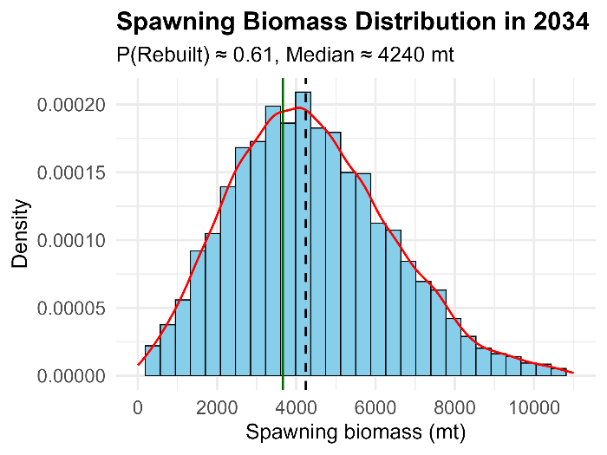

Figure 8.3. Projected distributions of WCNPO striped marlin female spawning biomass in 2025-27 (panels a-c) and 2034 (panel d) under Scenario 3 with 825 mt of annual carryover catch in 2025-2026 and with rebuilding target (green solid line), median spawning biomass and fitted densities (red curve).
(a) (b)
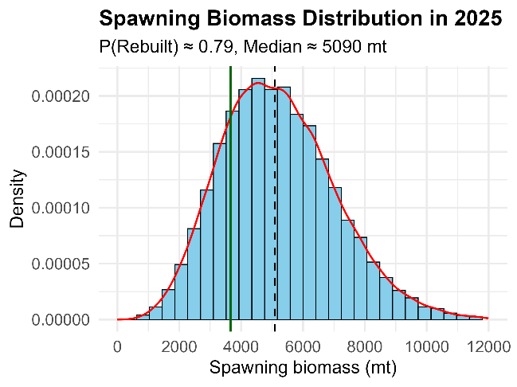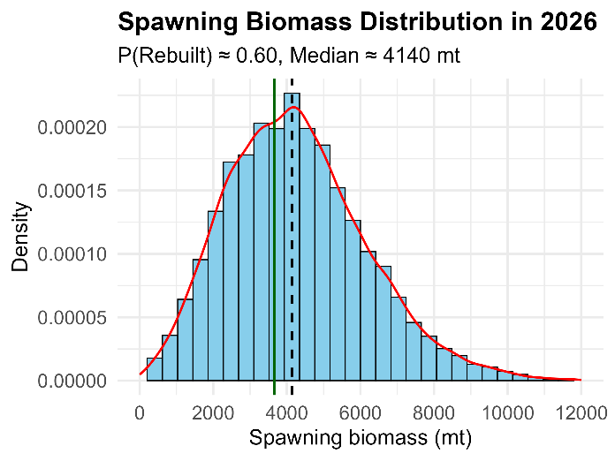
(c) (d)
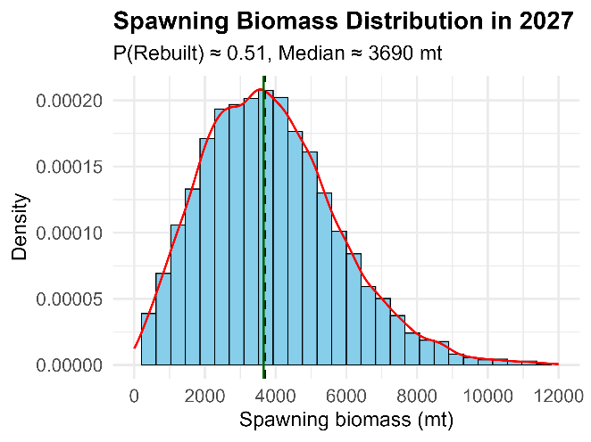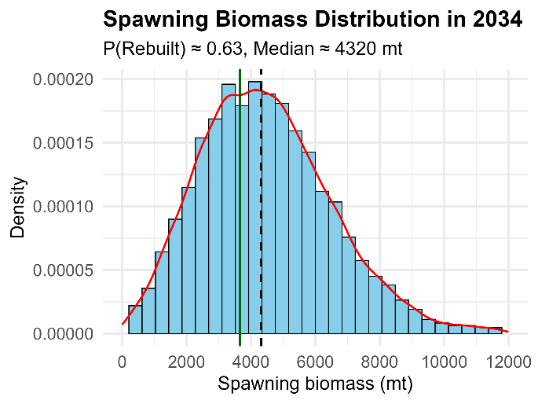
Figure 9.1. Projected distributions of WCNPO striped marlin fishing mortality in 2025-27 (panels a-c) and 2034 (panel d) under Scenario 1 with no carryover catch and with median fishing mortality (dashed black line), fishing mortality limit (dark blue solid line) and fitted densities (red curve).
(a) (b)
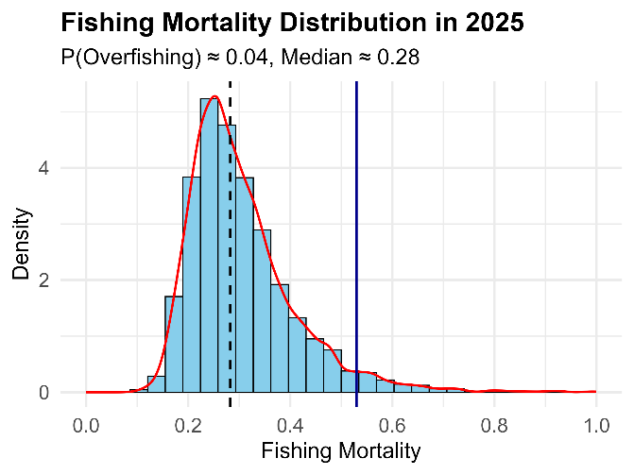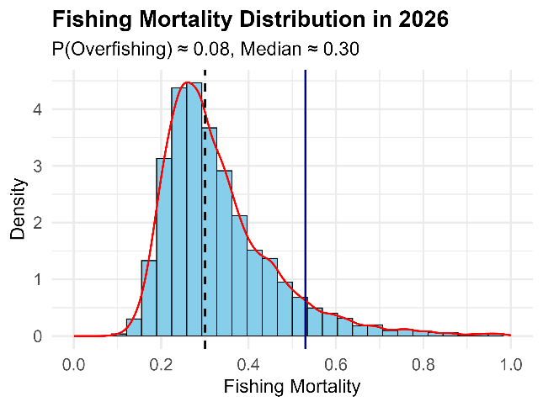
(c) (d)
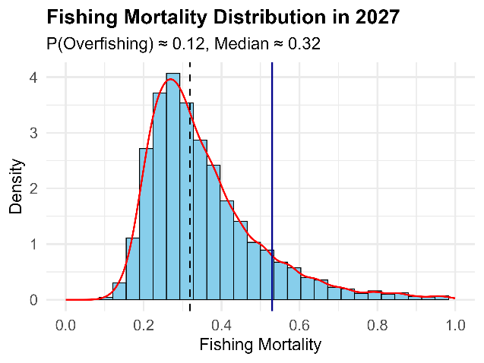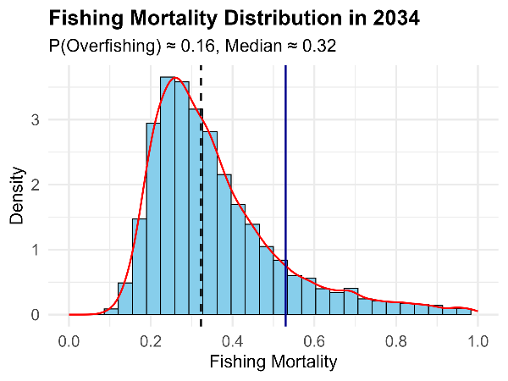
Figure 9.2. Projected distributions of WCNPO striped marlin fishing mortality in 2025-27 (panels a-c) and 2034 (panel d) under Scenario 2 with 825 mt of carryover catch in 2025 and with median fishing mortality (dashed black line), fishing mortality limit (dark blue solid line) and fitted densities (red curve).
(a) (b)
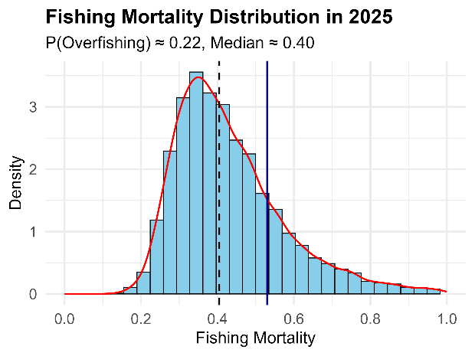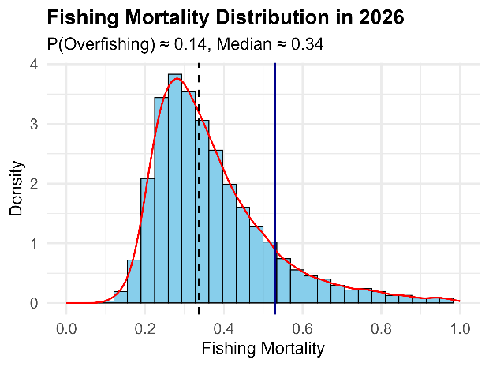
(c) (d)
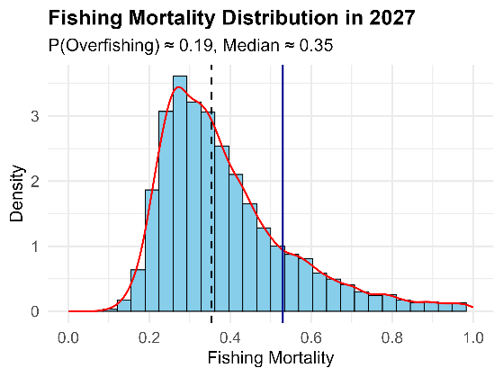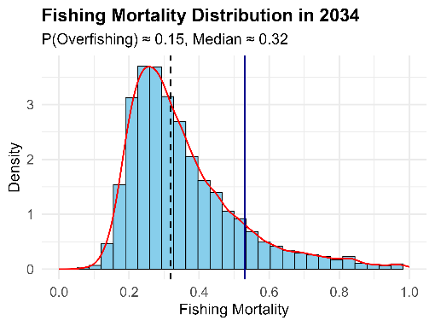
Figure 9.3. Projected distributions of WCNPO striped marlin fishing mortality in 2025-27 (panels a-c) and 2034 (panel d) under Scenario 3 with 825 mt of annual carryover catch in 2025-2026 and with median fishing mortality (dashed black line), fishing mortality limit (dark blue solid line) and fitted densities (red curve).
(a) (b)
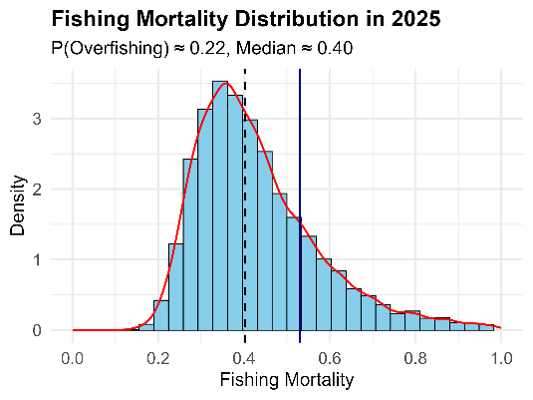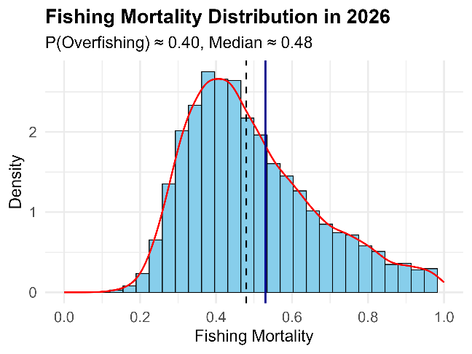
(c) (d)
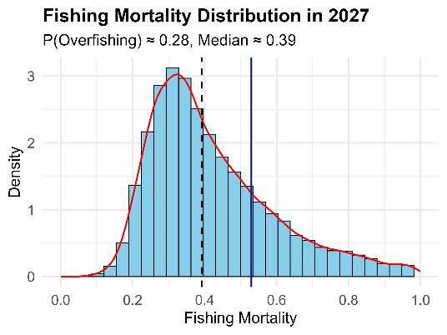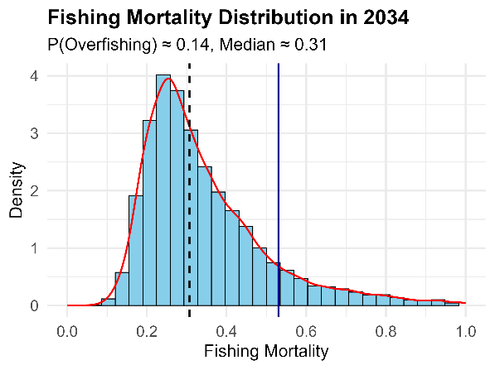
Figure 10.1. Projected distributions of WCNPO striped marlin female spawning biomass (top) and fishing mortality (bottom) under Scenario 1 with no carryover catch. Median (solid blue lines), interquartile range (dot-dashed lines), 10th and 90th percentiles (dotted blue lines), target biomass (green dashed line), overfishing limit (dashed red line), and approximate 80% confidence intervals (gray shaded region).
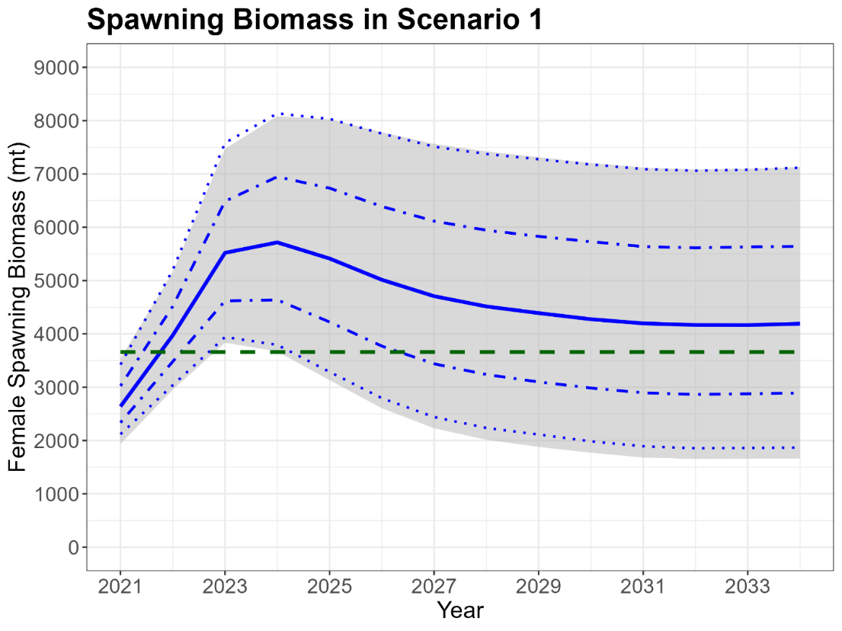
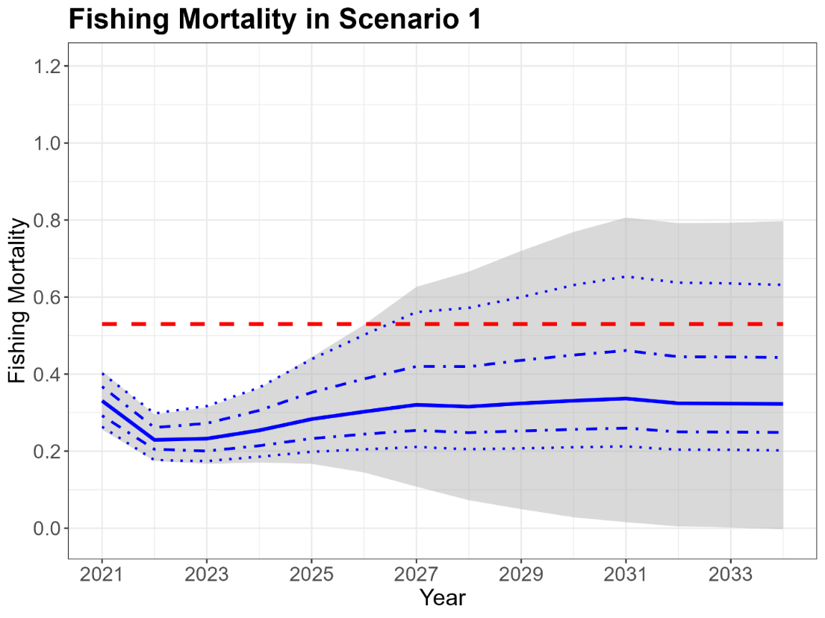
Figure 10.2. Projected distributions of WCNPO striped marlin female spawning biomass (top) and fishing mortality (bottom) under Scenario 2 with 825 mt of carryover catch in 2025. Median (solid blue lines), interquartile range (dot-dashed lines), 10th and 90th percentiles (dotted blue lines), target biomass (green dashed line), overfishing limit (dashed red line), and approximate 80% confidence intervals (gray shaded region).
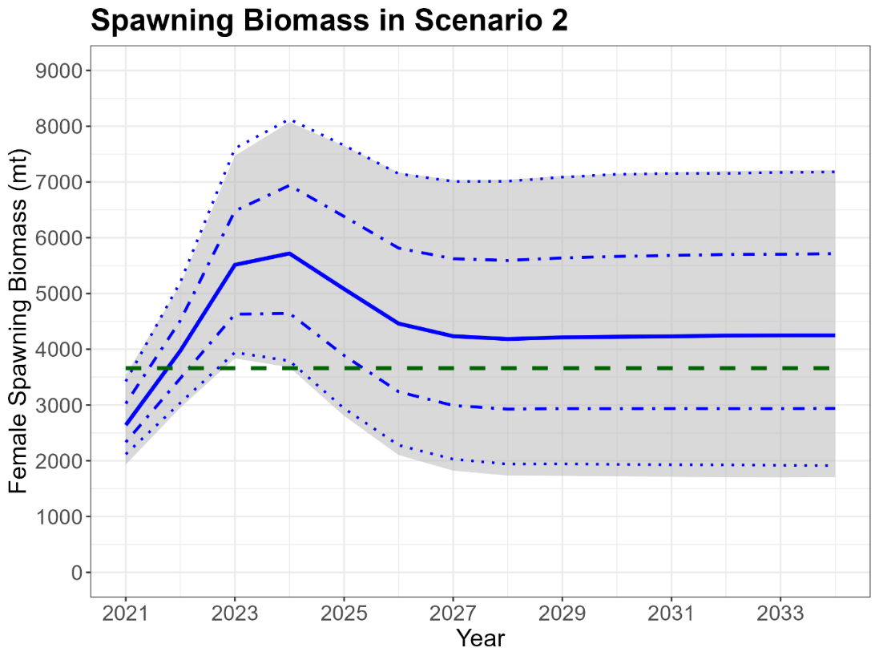
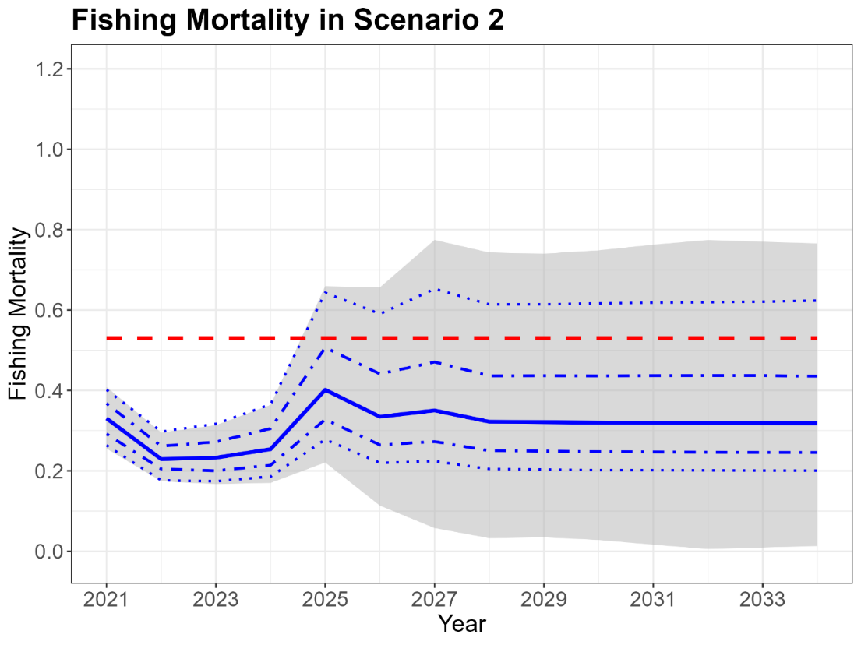
Figure 10.3. Projected distributions of WCNPO striped marlin female spawning biomass (top) and fishing mortality (bottom) under Scenario 3 with 825 mt of annual carryover catch in 2025-2026. Median (solid blue lines), interquartile range (dot-dashed lines), 10th and 90th percentiles (dotted blue lines), target biomass (green dashed line), overfishing limit (dashed red line), and approximate 80% confidence intervals (gray shaded region).
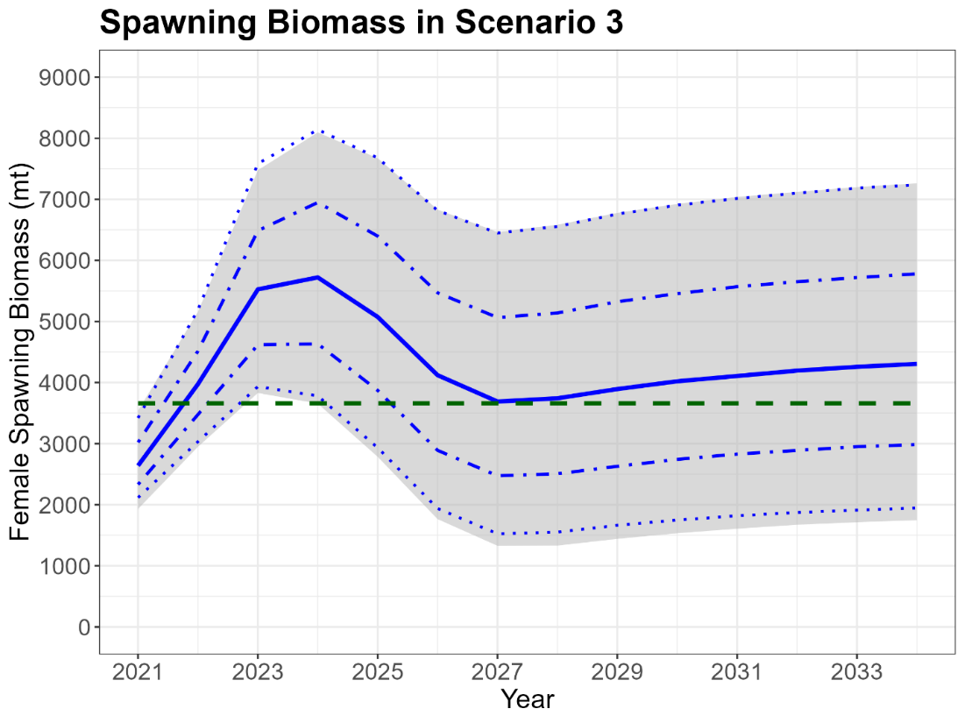
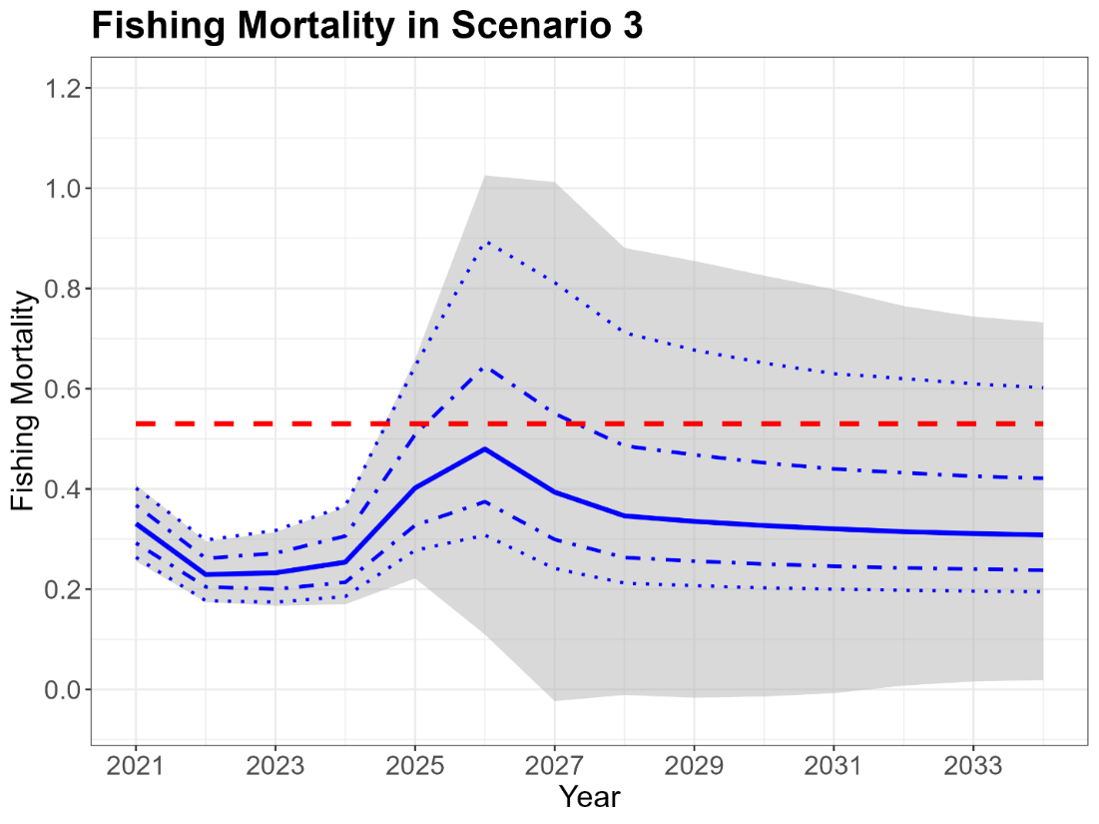
Figure 11.1. Projected probabilities (solid blue line) of rebuilding spawning biomass to achieve the target of 20%SSBF=0 (top) and fishing mortality exceeding the limit reference level of F_{20%SSB(F=0)} (bottom) under Scenario 1 with no carryover catch along with the 60% probability target (green dashed line).
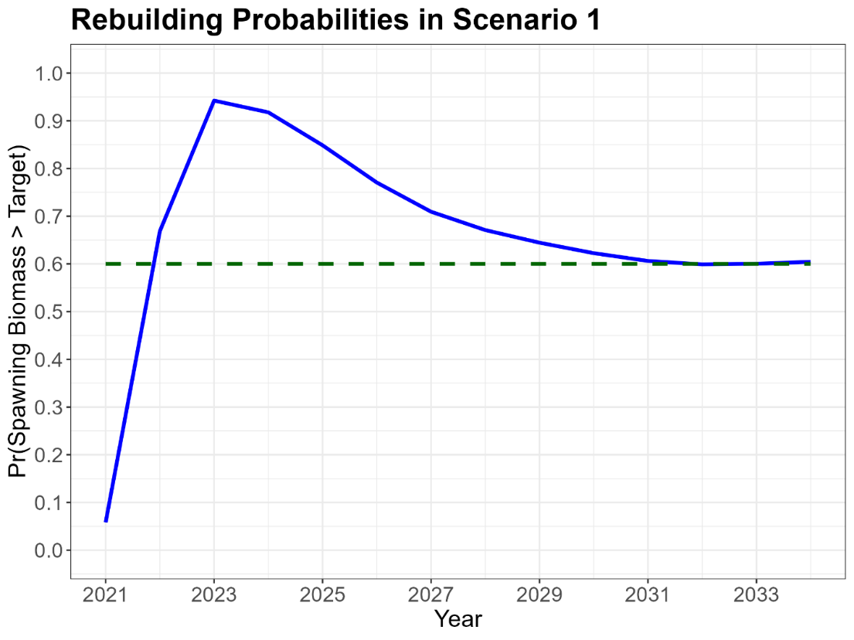
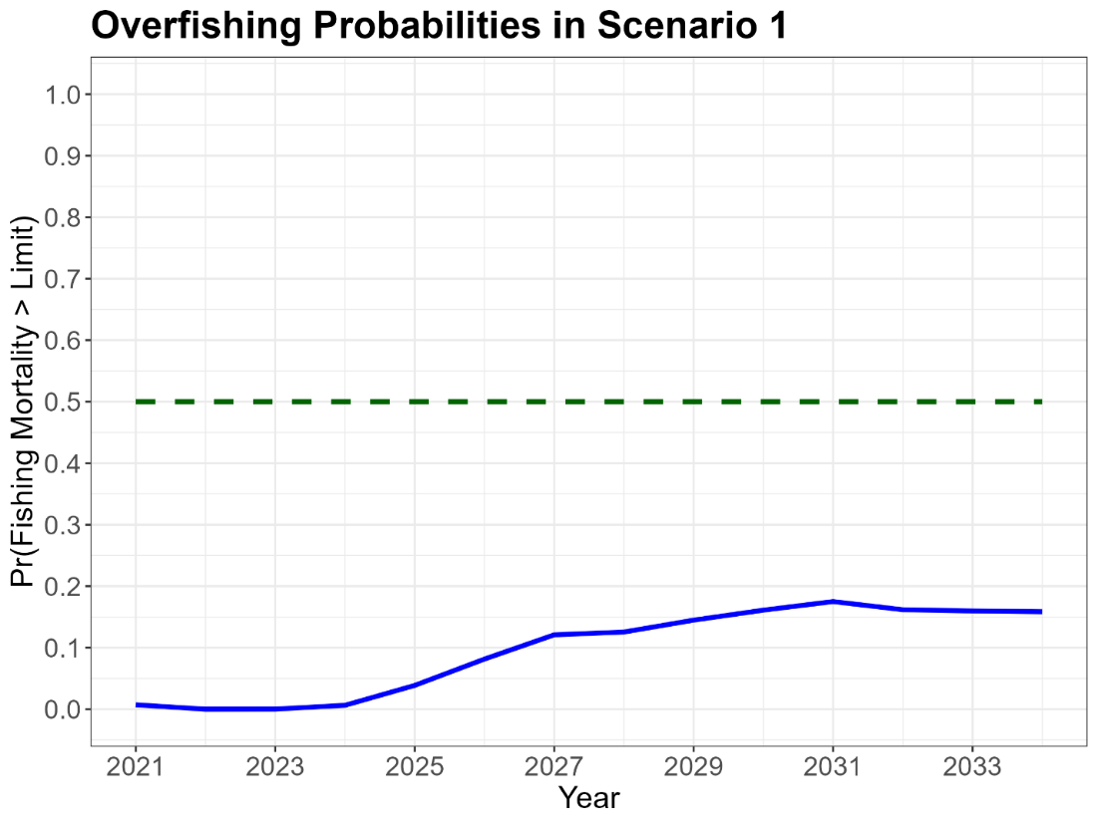

Figure 11.2. Projected probabilities (solid blue line) of rebuilding spawning biomass to achieve the target of 20%SSBF=0 (top) and fishing mortality exceeding the limit reference level of F_{20%SSB(F=0)} (bottom) under Scenario 2 with 825 mt of carryover catch in 2025 along with the 60% probability target (green dashed line).
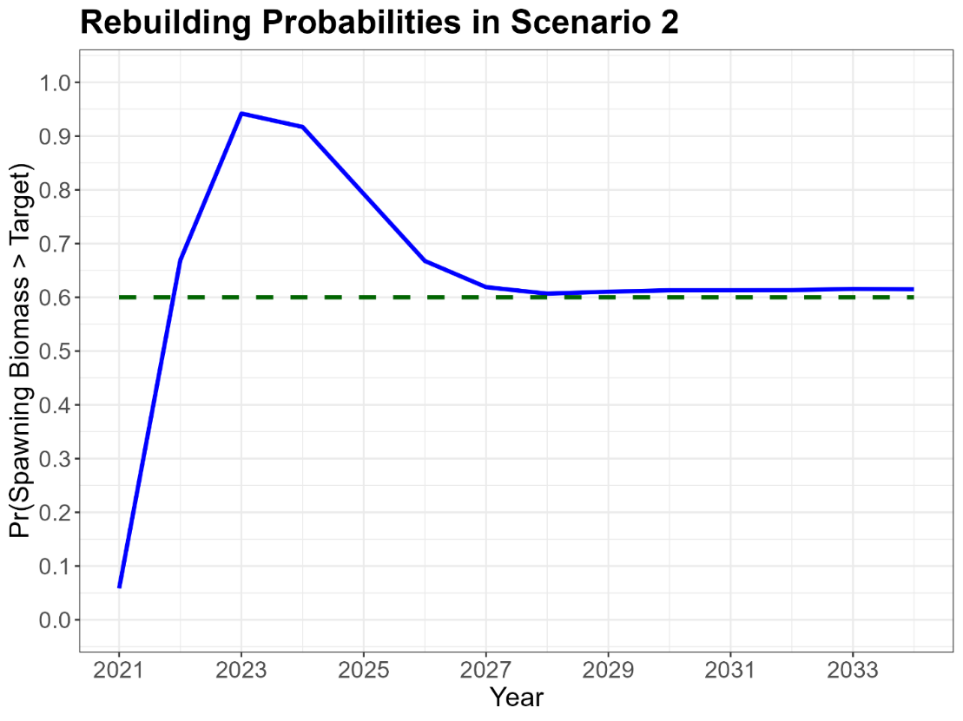
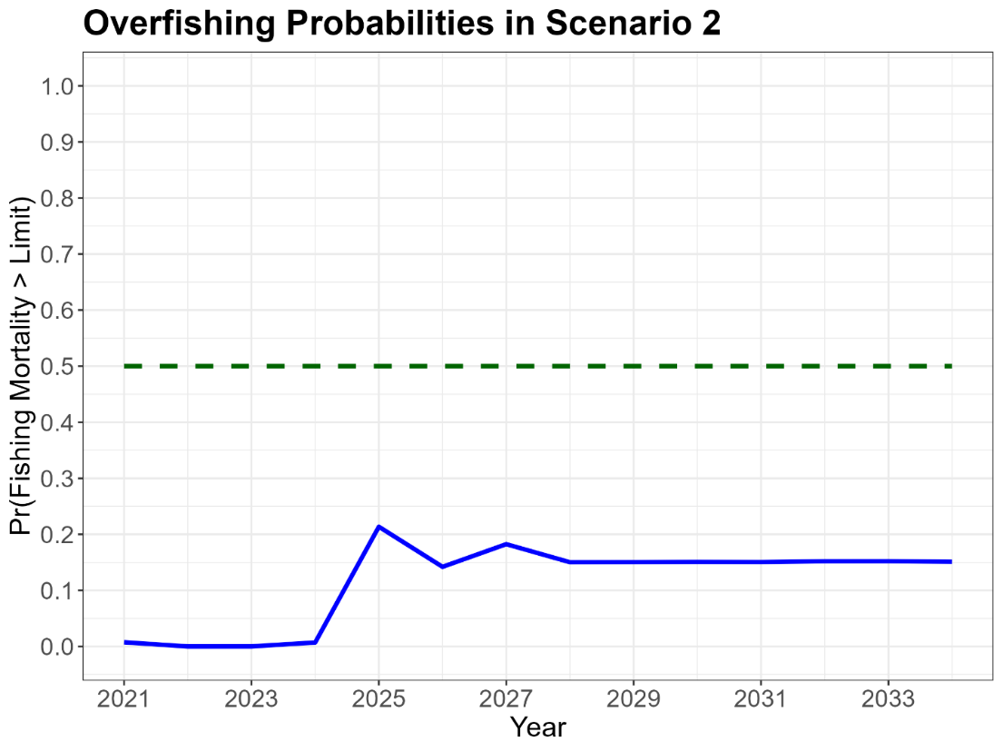
Figure 11.3. Projected probabilities (solid blue line) of rebuilding spawning biomass to achieve the target of 20%SSBF=0 (top) and fishing mortality exceeding the limit reference level of F_{20%SSB(F=0)} (bottom) under Scenario 3 with 825 mt of annual carryover catch in 2025-2026 along with the 60% probability target (green dashed line).
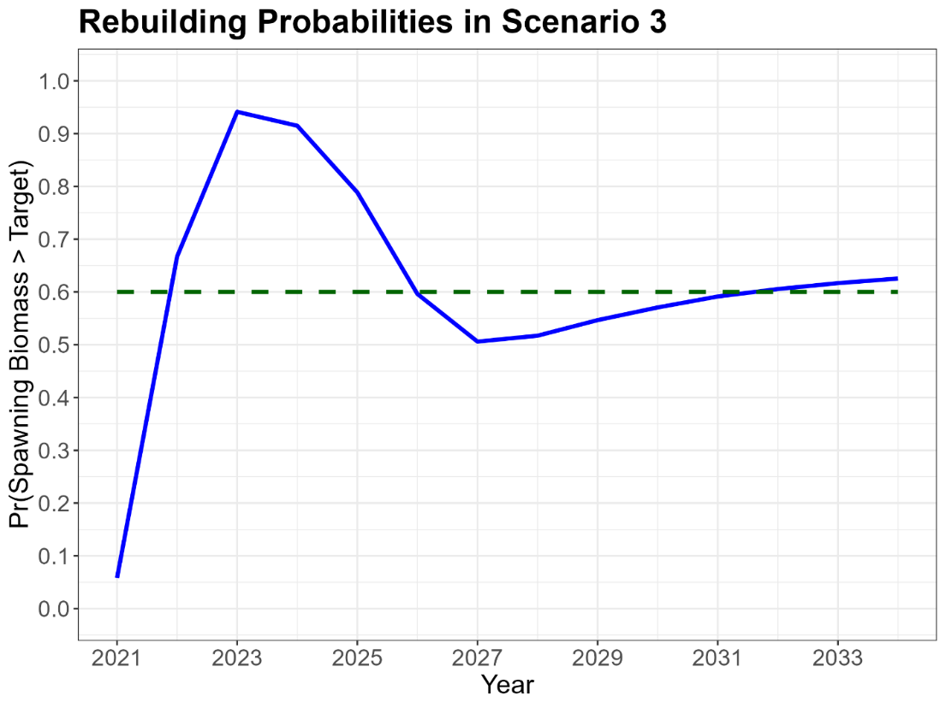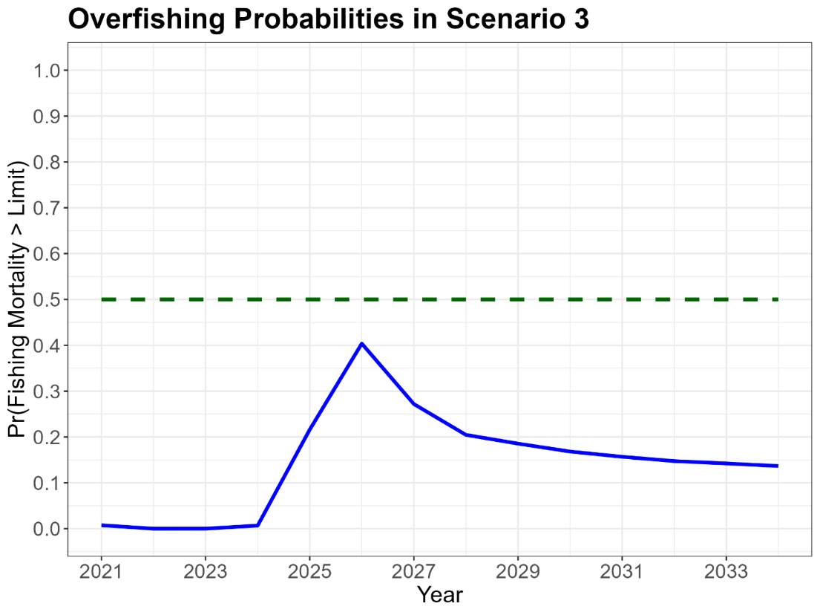
Figure 12. The time series of median spawning biomasses to rebuild the stock under Scenario 6 from the 2024 rebuilding analyses using a 3-phase catch = (2400, 2200, 2100) mt and where the 10th (P10), 40th (SSB Rebuild, blue line), and 90th (P90) percentiles of the annual spawning biomass distributions relative to the rebuilding target of 3,660 mt along with individual trajectories (grey lines) are shown.

Figure 13.1. Trends in WCNPO recruitment since 1977 where annual recruitment estimates are shown with 80% confidence intervals along with the average recruitment from the short-term recruitment model used in the stock projections.

Figure 13.2. Trends in recruitment and catch biomass of WCNPO striped marlin.

Figure 14. WCNPO striped marlin recruitment estimates from the 2023 benchmark stock assessment (ISC BILLWG 2023) along with the 2020 year class strength of about 208 thousand age-1 fish.

Figure 15.

Appendix.
Auxiliary plots of distributions of recruitment and population biomass by scenario.
Figure A1. Projected distributions of recruitment by scenario with median (solid blue lines), interquartile range (dot-dashed lines), 10th and 90th percentiles (dotted blue lines), average recruitment during 1977-2020 (green dashed line), and approximate 80% confidence intervals (gray shaded region).

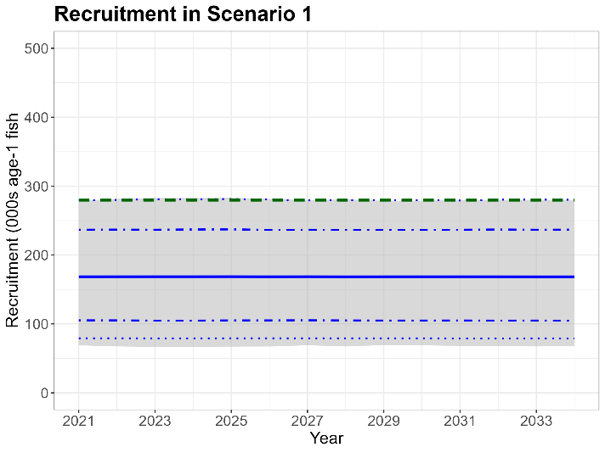
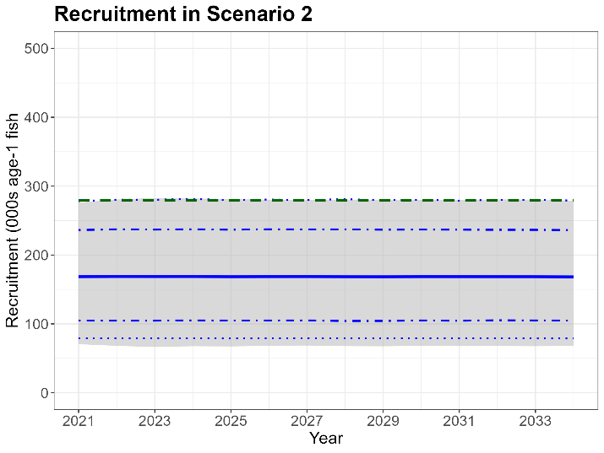
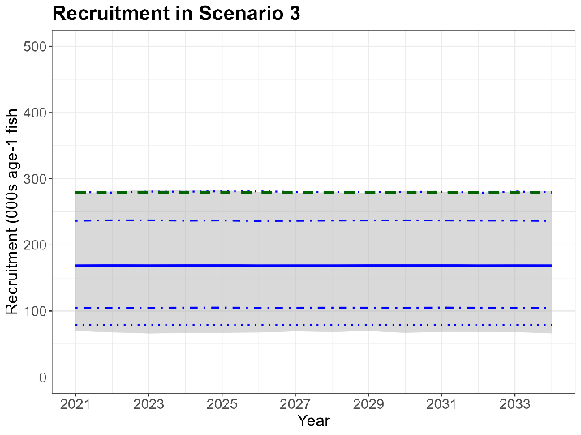

Figure A2. Projected distributions of WCNPO striped marlin population biomass by scenario with median (solid blue lines), interquartile range (dot-dashed lines), 10th and 90th percentiles (dotted blue lines), average population biomass during 2001-2020 (green dashed line), and approximate 80% confidence intervals (gray shaded region).

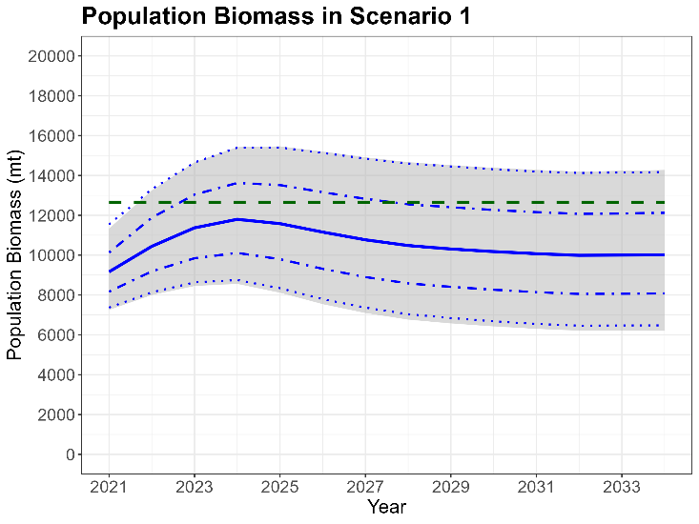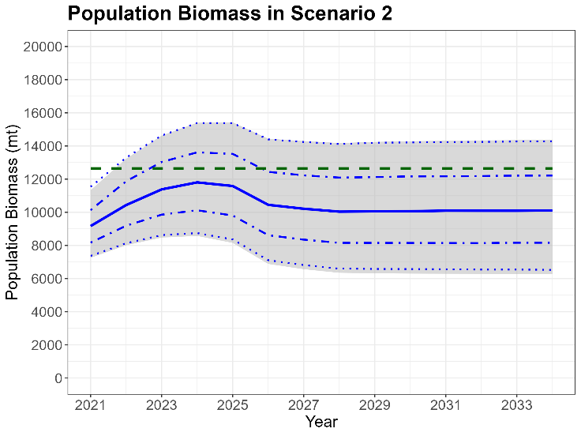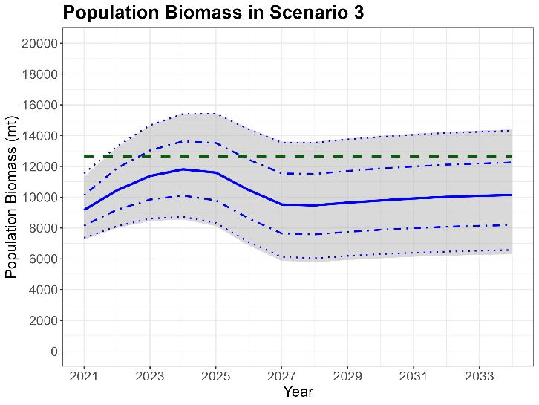

F_{20%SSB(F=0)} is the fishing mortality limit corresponding to the rebuilding target spawning biomass of 20%SSB_{F=0}.

